COMPILER DESIGN UNIT – 1 QUESTIONS

- What is Compiler?
- What are Translators? Why do we need Translators?
- What does a Compiler do?
- What is assembler?
- What is assembly language?
- What are the different phases of compiler?
- What are the types of phases in compiler?
- What are compiler construction tools. Explain any three.
- What phases of compiler comes under front-end and back-end? Why are they called so?
- Explain all phases of compiler in brief?
- Draw a neat diagram of compiler with all its phases.
- What are cross compiler? Explain with example.
- What is bootstrapping? Explain with help of a diagram? Give example.
- What is quick and dirty compiler?
- What is a lexical token?
- What is a symbol table in compiler? Explain with the help of an example.
- Explain the role of Lexical Analysis in detail with help of a diagram.
- What is FLEX?
- What is YACC?
- What is Input Buffering? What are is disadvantages?
- Design a FA from given regular expression 10 + (0 + 11)0* 1.
- Design a NFA from given regular expression 1 (1* 01* 01*)*.
- Construct the FA for regular expression 0*1 + 10.
- Minimize the given DFA-
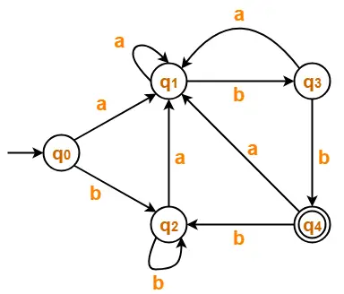

- Minimize the given DFA-
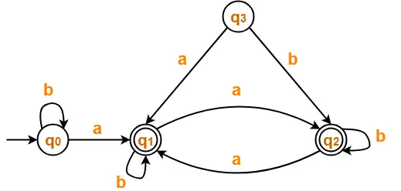

- Minimize the given DFA-
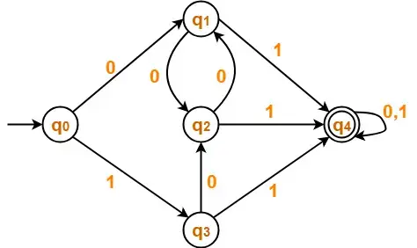

PYQ:
- Generate a pattern matcher which can recognise the following patters: 01* and 1*0
- Write short note on LEX and LEX tool.
- What is Single pass and Multi pass Compiler?
- What are Pattern in Lexical Analyser?
- What is interpreter?
- Difference between compiler and interpreter.
- What is Translator? Differentiate between an interpreter and a compiler in terms of functionality.
- Define the term "compiler" and explain its role in the context of programming languages. Also explain structure and phases of a compiler in detail.
- How do we implement lexical analyzer? Explain step by step (7) procedure for implementing lexical analyzer for the following LEX program:
AUXILLARY DEFINITIONS:
(none)
TRANSLATION RULES:
a {} /* Actions are omitted here*/
abb {}
a*b+ {}
- Write step by step procedure to construct the NFA for the following regular expression: R= (a | b)*abb
- What is input buffering? How it helps in construction of compiler? Explain.

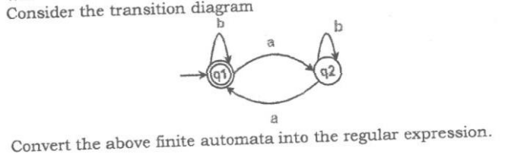

COMPILER DESIGN UNIT – 2 QUESTIONS

- What is the Role of the parser?
- What is Annotated Parse Tree?
- What is handle pruning? With example.
- Discuss Context Free Grammar taking a suitable example.
- A left recursive grammar cannot be LL(1). justify.
- Discuss all the three methods used to perform LR parsing. Which is most powerful and why?

- How to remove ambiguity from grammar? Remove ambiguity from the following grammar:

E -> E+E/E*E/(E)/id

- How to remove left recursion from grammar? Remove Left Recursion from the following grammar:

E-> E+&/Q

- How to convert NFA to DFA?

- Find the FIRST and FOLLOW of the following grammar:
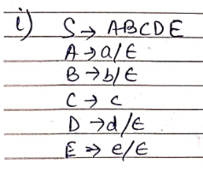
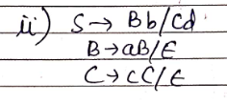
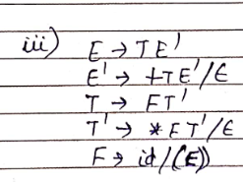

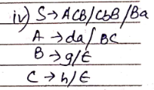

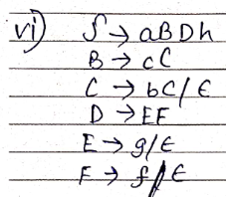

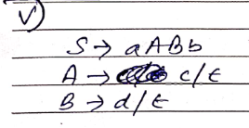

- Draw the parse tree using LL(1) Parser, string is id*id+id:

E -> E+E/E*E/(E)/id

- Draw the parse tree using LL(1) Parser, string is abd:

S-> A
A-> aB/Ad
B-> b
C-> g

- Draw the parse tree using LL(1) Parser:

S-> aSbS/bSaS/null

- Perform Shift Reduce Parsing on the following Grammar for input a1-(a2+a3):

S → S+S
S → S-S
S → (S)
S → a

- Consider the following Grammar and construct the Operator Precedence Parsing. Given string is id+id*id:

E -> EAE/id
A-> +/*

- Make a parse tree using LR(0) parsing with following grammar:

a) E-> BB
B-> CB/d
input = ccdd$

b) S-> AA
A-> aA/b

- Check whether the grammar is LR(0) or SLR(1) or not.

E-> T+E/T
T-> id

- Make the parse tree for grammar:

E-> BB
B-> CB/d

Using CLR(1) and LALR(1)

PYQ:

- Improve the grammar by removing left recursion:

S-> AaB/b
A-> Aab/Aba/a
B-> a

- Calculate and FIRST and FOLLOW for non-terminal then create predictive parsing table and prove that this grammar is not LL(1).

X-> 0Y1/1Z2
Y-> 2/null
Z-> 1Y2/1/null

- Consider the Grammar:

S-> L=R/R
L-> *R/id
R-> L

Design LALR Parser for this Grammar.

22) Define the term "parser" and its role in the context of compiler design.
23)What is left recursion? Eliminate left recursion from the following grammar:
E-> E+T/T
T->T*F/F
F-> (E) | id

All Answers: Unit – 1

1. Ans.

A compiler is a computer program that helps in translating the computer code from one programming language into another language

2. Ans.

A translator is a program that converts instructions written in source code to object code or from high-level to machine language.

3. Ans.

A compiler is a software that converts the source code to the object code. In other words, we can say that it converts the high-level language to machine/binary language. Moreover, it is necessary to perform this step to make the program executable. This is because the computer understands only binary language.

4. Ans.

For every platform (Hardware + OS) we will have an assembler. They are not universal since for each platform we have one. The output of assembler is called object file. Its translates assembly language to machine code.

5. Ans.

An assembly language is a type of low-level programming language that is intended to communicate directly with a computer's hardware. Unlike machine language, which consists of binary and hexadecimal characters, assembly languages are designed to be readable by humans.

6 & 7. Ans.

(i) Analysis Phase – An intermediate representation is created from the give source code :
1. Lexical Analyser
2. Syntax Analyser
3. Semantic Analyser

Lexical analyser divides the program into “tokens”, Syntax analyser recognizes “sentences” in the program using syntax of language and Semantic analyser checks static semantics of each construct.

(ii) Synthesis Phase – Equivalent target program is created from the intermediate representation. It has three parts:
1. Intermediate Code Generator
2. Code Optimizer
3. Code Generator

Intermediate Code Generator generates “abstract” code, Code Optimizer optimizes the abstract code, and final Code Generator translates abstract intermediate code into specific machine instructions.

8. Ans.

Compiler Construction Tools
Compiler construction involves specialized tools that simplify the creation of compilers, helping in various phases such as lexical analysis, syntax analysis, and code generation.

1. Parser Generators
- Purpose: Generate parsers from context-free grammar.
- Use: Automates syntax analysis, saving time and reducing complexity.
- Examples: Yacc, Bison, ANTLR.

2. Scanner Generators
- Purpose: Generate lexical analyzers from regular expressions.
- Use: Tokenizes source code into meaningful symbols.
- Examples: Lex, Flex, JFlex.

3. Syntax Directed Translation Engines
- Purpose: Produce intermediate code from parse trees.
- Use: Associates semantic actions with syntax rules to generate intermediate code.
- Examples: SableCC, ANTLR.

4. Automatic Code Generators
- Purpose: Convert intermediate code to machine code.
- Use: Translates high-level instructions to machine-specific code.
- Examples: GCC, LLVM.

5. Data-flow Analysis Engines
- Purpose: Optimize code by analyzing data flow.
- Use: Improves code efficiency by identifying redundancies.
- Examples: LLVM optimization passes, SSA form.

6. Compiler Construction Toolkits
- Purpose: Provide integrated routines for building compiler components.
- Use: Streamlines compiler development with reusable tools.
- Examples: LLVM, ANTLR.

9. Ans.

Compiler Phases
- Analysis Phase: (Front-End)
  - Converts source code to an intermediate representation (IR) through lexical, syntactic, and semantic analysis.
  - Tools: Scanner Generators (Lex), Parser Generators (Yacc), Translation Engines.

- Synthesis Phase: (Back-End)
  - Translates IR into machine code, applying optimizations.
  - Tools: Data-flow Engines, Automatic Code Generators.
10. Ans.
Refer to answer 6 & 7.

11. Ans.
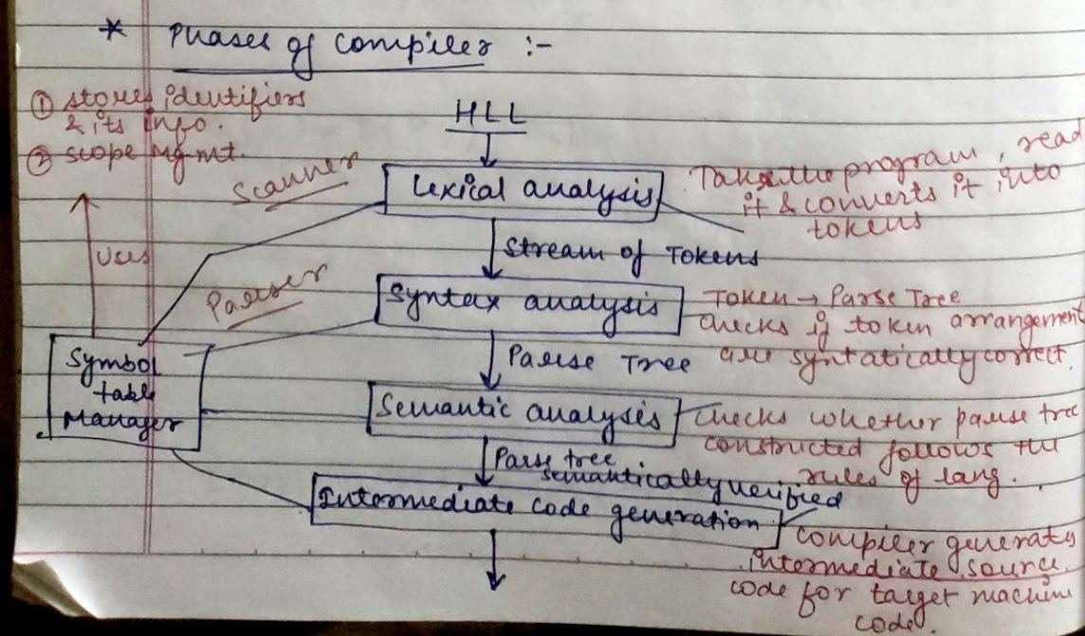

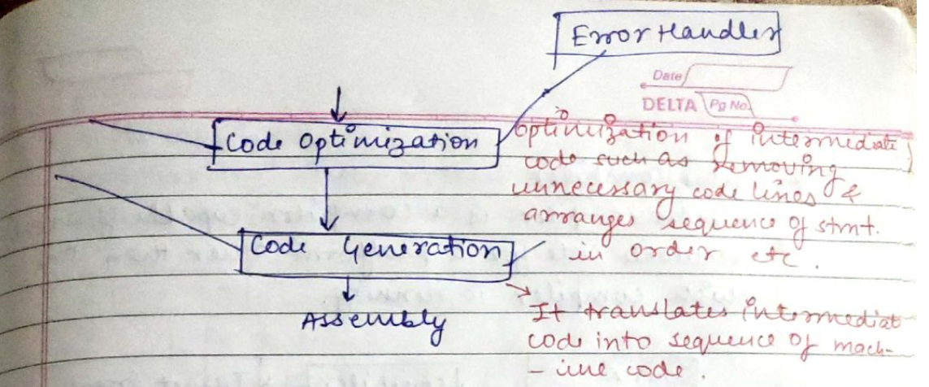

12. Ans.

A Cross Compiler is a type of compiler that runs on one machine (called the host machine) but produces executable code for a different machine (called the target machine).

For example, if a cross compiler is running on Machine A (host machine) but generates code that can execute on Machine B (target machine), it allows developers to build software for different architectures or platforms without requiring the target hardware during development.

Widely used in embedded systems development, where the target machine might be a different hardware architecture (e.g., ARM) from the development environment (e.g., x86).

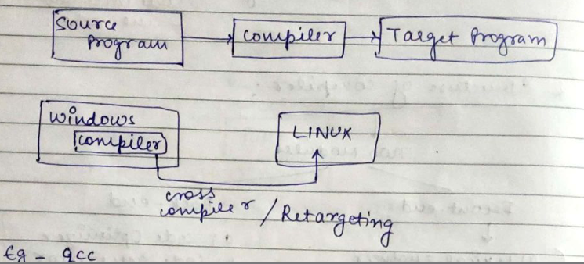

Advantages of Cross Compilers
- Targeting Different Architectures: Allow development of code for a platform different from the host machine, essential for embedded systems.
- Development Flexibility: Enable use of powerful host machines while targeting less capable hardware.
- Time Efficiency: Reduce build times by compiling on a powerful machine before deploying to the target.
- Enhanced Debugging: Improve debugging capabilities by allowing testing in a familiar environment.
- Support for Multiple Platforms: Facilitate development for various platforms, enabling code reusability.
- Legacy Support: Maintain and update applications for older systems where native compilers may not be available.

13. Ans.

Bootstrapping is a process in which simple language is used to translate more complicated program which in turn may handle for more complicated program. This complicated program can further handle even more complicated program and so on. Writing a compiler for any high level language is a complicated process. It takes lot of time to write a compiler from scratch.

First we write a compiler for a small of C in assembly language. Then using with small subset of C i.e. C0, for the source language c the compiler is written. Finally we compile the second compiler. using compiler 1 the compiler 2 is compiled.

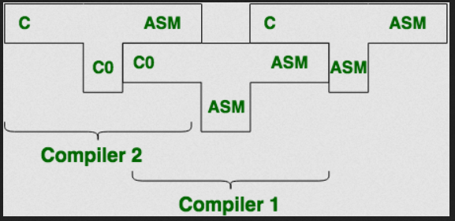

we get a compiler written in ASM which compiles C and generates code in ASM.

14. Ans.

A Quick and Dirty Compiler is a simple, often hastily developed compiler that prioritizes getting basic functionality working over optimization and robustness. These compilers are usually created to achieve a working solution rapidly, often sacrificing performance, error handling, and comprehensive features for the sake of speed in development.

15. Ans.

A lexical token is a sequence of characters that can be treated as a unit in the grammar of the programming languages

Lexeme: The sequence of characters matched by a pattern to form the corresponding token or a sequence of input characters that comprises a single token is called a lexeme. eg- “float”, “abs_zero_Kelvin”, “=”, “-”, “273”, “;”

16. Ans.

The Symbol Table is a crucial data structure used by the compiler during both the analysis and synthesis phases. It stores important information about the identifiers (such as variables, functions, objects, etc.) in the source code, including their names, types, scopes, and memory locations.

Why is the Symbol Table Important?
- Fast Access: Enables the compiler to find identifiers and their attributes quickly during parsing, semantic analysis, and code generation.
- Error Checking: Helps in type checking, ensuring that variables and functions are used correctly.
- Efficient Code Generation: Facilitates efficient code generation by storing information about memory locations and variable types.
17. Ans.
A Lexical Analyzer (also called a scanner) is the first phase of a compiler. It reads the source code character by character and converts it into meaningful tokens, which are the basic building blocks for syntax analysis. The lexical analyzer simplifies the source code for further processing by breaking it down into tokens.

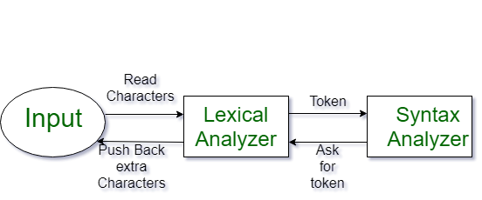

What does the Lexical Analyzer do?
- Input: It takes raw source code as input (a stream of characters).
- Output: It generates a sequence of tokens, each representing a specific category (e.g., keywords, operators, identifiers, literals).
- Role: It removes unnecessary details like whitespace and comments, leaving only the core meaningful symbols.

Step-by-Step Process of Lexical Analysis:
- Reading Source Code:
  - The lexical analyzer reads the source code character by character from left to right.
  - It groups characters into tokens, such as keywords (int, while), identifiers (variableName), operators (+, =), and literals (123, "string").
- Tokenization:
  - The primary job of the lexical analyzer is tokenization. Each token is a sequence of characters representing a meaningful unit in the programming language.
  - Example:
    - Source code: int x = 10;
    - Tokens: int (keyword), x (identifier), = (operator), 10 (literal), ; (delimiter).
- Pattern Matching Using Regular Expressions:
  - The lexical analyzer matches sequences of characters against predefined patterns (usually regular expressions) to identify valid tokens.
  - Example Patterns:
    - Identifiers: [a-zA-Z_][a-zA-Z0-9_]*
    - Integers: [0-9]+
    - Operators: +, -, =, etc.
- Removing Whitespace and Comments:
  - Whitespace (spaces, tabs, newlines) and comments are not relevant to syntax analysis, so they are ignored by the lexical analyzer.
- Error Handling:
  - The lexical analyzer must detect lexical errors, such as invalid characters or improperly formed tokens.
  - Example of errors:
    - Unrecognized characters like # in a language that doesn't support it.
    - Malformed numbers or identifiers, like 123abc (if not allowed).
- Symbol Table Insertion:
  - The lexical analyzer often interacts with the symbol table, particularly when it encounters identifiers (variable names, function names, etc.).
  - When a new identifier is found, the lexical analyzer may add it to the symbol table with information like its type and scope.
- Return Tokens to Parser:
  - After identifying and creating tokens, the lexical analyzer sends them to the parser (the next phase) for syntactic analysis.
  - Each token consists of:
    - Token name/type: Classifies the token (e.g., KEYWORD, IDENTIFIER, NUMBER).
    - Token value: The actual string/character sequence from the source code (e.g., int, x, 10).
    - Location (optional): The line number or position in the source code for error reporting.

Example of Lexical Analysis Process:
Given the following source code snippet:
int a = 5;
The lexical analyzer performs the following steps:
- Reads characters: i, n, t, recognizes int as a keyword.
- Reads whitespace and skips it.
- Reads a, recognizes it as an identifier.
- Reads =, recognizes it as an assignment operator.
- Reads 5, recognizes it as a numeric literal.
- Reads ;, recognizes it as a delimiter.
- Generates tokens for the parser:
  - KEYWORD (int)
  - IDENTIFIER (a)
  - ASSIGNMENT (=)
  - LITERAL (5)
  - DELIMITER (;)
18. Ans.

Flex (Fast Lexical Analyzer Generator )
FLEX (fast lexical analyzer generator) is a tool/computer program for generating lexical
analyzers (scanners or lexers) written by Vern Paxson in C around 1987. It is used
together with Berkeley Yacc parser generator or GNU Bison parser generator.

Flex and Bison both are more flexible than Lex and Yacc and produces faster code.
Bison produces parser from the input file provided by the user. The function yylex() is
automatically generated by the flex when it is provided with a .l file and this yylex()
function is expected by parser to call to retrieve tokens from current/this token stream.

19. Ans.

YACC is an LALR parser generator developed at the beginning of the 1970s by Stephen C. Johnson for the Unix operating system. It automatically generates the LALR(1) parsers from formal grammar specifications. YACC plays an important role in compiler and interpreter development since it provides a means to specify the grammar of a language and to produce parsers that either interpret or compile code written in that language.
20 Ans.

Input Buffering is a technique used in compiler design to improve the efficiency of reading and processing characters from the source code during the lexical analysis phase. It is used by the lexical analyzer (or scanner) to avoid reading characters from the source program one by one, which can be slow and inefficient. Instead, the source code is loaded into a buffer, typically in larger chunks, allowing the lexical analyzer to process characters more quickly.

Advantages of Input Buffering:
- Reduces I/O Operations: Instead of reading characters one by one from disk or memory, the source code is read in chunks, which reduces costly I/O operations.
- Faster Lexical Analysis: By loading multiple characters at once, the lexical analyzer can process tokens more quickly.
- Efficient Memory Management: The dual-buffer approach allows continuous processing without waiting for input.

21. Ans.

10 + (0 + 11)0* 1.
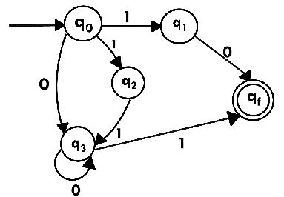

22. Ans.

1 (1* 01* 01*)*.

23. Ans

24. Ans.
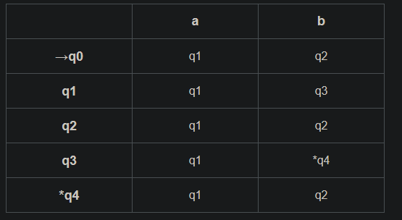

Now using Equivalence Theorem, we have-
P0 = { q0 , q1 , q2 , q3 } { q4 }
P1 = { q0 , q1 , q2 } { q3 } { q4 }
P2 = { q0 , q2 } { q1 } { q3 } { q4 }
P3 = { q0 , q2 } { q1 } { q3 } { q4 }

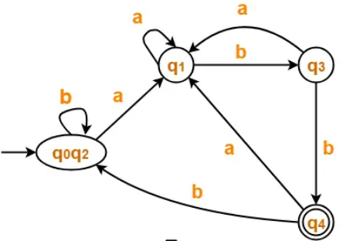

28. Ans.

Single-Pass Compiler
- Definition: Processes source code in one pass, generating code immediately.
- Characteristics:
  - One Pass: Reads and compiles the code once.
  - Immediate Code Generation: Generates target code while scanning.
- Advantages:
  - Faster compilation and lower memory usage.
- Disadvantages:
  - Limited error detection and complex implementations for complex languages.
- Example: Used for simple programming languages.

Multi-Pass Compiler
- Definition: Processes source code in multiple passes, analyzing and generating code separately.
- Characteristics:
  - Multiple Passes: Reads and processes the code several times.
  - Intermediate Representation: Generates intermediate code for further analysis.
- Advantages:
  - Thorough analysis and optimizations; easier implementation of complex features.
- Disadvantages:
  - Slower compilation and higher memory usage.
- Example: Used for complex programming languages like C, C++, or Java.

29. Ans.
LEX is a powerful tool used for generating lexical analyzers or scanners, which are essential components of compilers and interpreters. It is a type of scanner generator that takes a set of regular expressions and generates C code for a lexical analyzer that recognizes the specified patterns in the input text.

LEX is an essential tool in the field of compiler design and programming language development, enabling the efficient creation of lexical analyzers through the use of regular expressions and automated code generation. It plays a crucial role in processing source code, facilitating the development of complex programming languages and applications

Advantages of LEX:
- Ease of Use: LEX simplifies the process of creating lexical analyzers by automating token generation.
- Regular Expressions: It uses regular expressions, which are a powerful and concise way to describe patterns.
- Integration: Easily integrates with YACC for full compiler design.

Disadvantages of LEX:
- C Language Dependency: LEX generates C code, making it less suitable for projects that use other programming languages.
- Learning Curve: Although powerful, understanding regular expressions and how to effectively use LEX can require some time and practice.
30. Ans.

In the context of a lexical analyzer, a pattern refers to a specific sequence or structure that defines a category of tokens in the source code. Patterns are typically described using regular expressions, which allow the lexical analyzer to recognize and classify different types of input characters or strings.

Ex. int x = 10;
if (x > 5) {
printf("x is greater than 5");
}
Patterns:
- Keyword (int, if): int|if
- Identifier (x): [a-zA-Z_][a-zA-Z0-9_]*
- Integer Literal (10): [0-9]+
- Operator (=, >): =|>
- String Literal ("x is greater than 5"): "[^"]*"

31. An interpreter is a program that executes code line by line, translating high-level code into machine code at runtime. This allows for immediate execution but may be slower than compiled programs, as each line is processed every time the code runs.

32. Differences between a compiler and an interpreter:
- Execution: A compiler translates the entire code into machine code before execution, creating an executable file. An interpreter translates and runs code line by line.
- Speed: Compiled code generally runs faster since it's pre-translated, while interpreted code can be slower due to real-time translation.
- Error Handling: Compilers catch all syntax errors before execution, while interpreters stop at the first error encountered during execution.
- Usage: Languages like C and C++ use compilers, while languages like Python and JavaScript typically use interpreters.

- What is Translator? Differentiate between an interpreter and a compiler in terms of functionality.
A translator in the context of programming is a tool or software that converts a program written in one programming language into another language, typically into machine code or an intermediate form. The translation process can involve compiling, interpreting, or a combination of both.

Interpreter vs Compiler
Both interpreters and compilers are types of translators, but they differ in how they translate code and how they execute the program.

Interpreter
- Functionality: An interpreter translates and executes code line-by-line or statement-by-statement. It does not generate an output file, and instead directly executes the code during the translation process.
- Execution Process: It reads the source code, interprets it, and immediately executes the instructions.
- Error Detection: Errors are detected and reported during execution, typically one at a time as the program runs.
- Speed: Interpreters are generally slower because they translate code at runtime.
- Example Languages: Python, JavaScript, Ruby.

Compiler
- Functionality: A compiler translates the entire source code into machine code (or an intermediate form like bytecode) in one go, generating an output file (usually an executable) that can be run independently.
- Execution Process: It translates the whole program before any execution begins. Once compiled, the program can be executed multiple times without recompilation.
- Error Detection: Compilers detect errors in the entire program before any execution takes place, typically providing all errors at once.
- Speed: Compiled programs are generally faster to execute since the translation happens beforehand.
- Example Languages: C, C++, Java (when compiling to bytecode).

Key Differences
Feature | Interpreter | Compiler
Translation Type | Line-by-line or statement-by-statement | Entire program at once
Execution Time | Executes immediately as it translates | Executes after complete translation
Error Detection | Detects errors during execution (one at a time) | Detects all errors before execution
Output | No intermediate output; executes directly | Produces an executable or intermediate code
Speed of Execution | Slower execution | Faster execution after compilation
Example Languages | Python, JavaScript, Ruby | C, C++, Java (compiled to bytecode)
In summary, an interpreter translates and executes code line-by-line, while a compiler translates the entire program before execution. Each has its trade-offs in terms of execution speed, error handling, and development workflow.

- Define the term "compiler" and explain its role in the context of programming languages. Also explain structure and phases of a compiler in detail.
A compiler is a specialized program that translates high-level programming code (written in a source language) into machine code, bytecode, or an intermediate language. The output of a compiler is usually a file containing machine code or an executable, which the computer can run directly. The primary role of a compiler is to bridge the gap between human-readable code and machine-readable instructions that a computer can execute.
The key function of a compiler is to translate a program's source code into a form that the hardware can understand, while also ensuring that the translation preserves the meaning and behavior of the original code.

Role of a Compiler in Programming Languages
A compiler plays an essential role in programming languages as it:
- Enables Translation: It translates code written in high-level programming languages (like C, C++, Java) into machine-readable code or bytecode.
- Optimization: It can optimize the code for better performance, including improving runtime efficiency, reducing memory usage, and minimizing instructions.
- Error Checking: During the compilation process, the compiler identifies syntax errors, type errors, and other issues in the code, providing feedback to the programmer.
- Code Generation: It generates an executable code that can be run on the target system.

- How do we implement lexical analyzer? Explain step by step procedure for implementing lexical analyzer for the following LEX program:
AUXILLARY DEFINITIONS:
(none)
TRANSLATION RULES:
a {} /* Actions are omitted here*/
abb {}
a*b+ {}
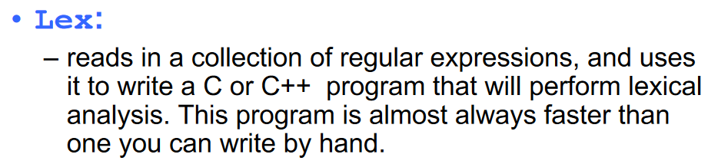
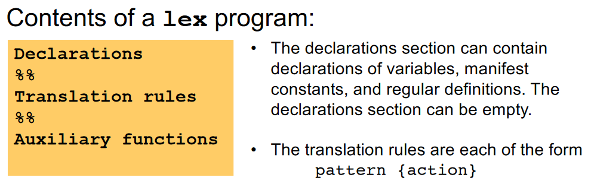
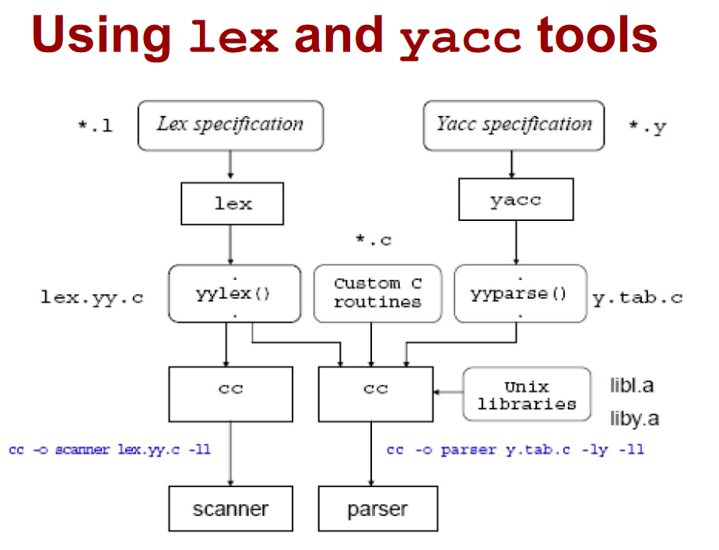

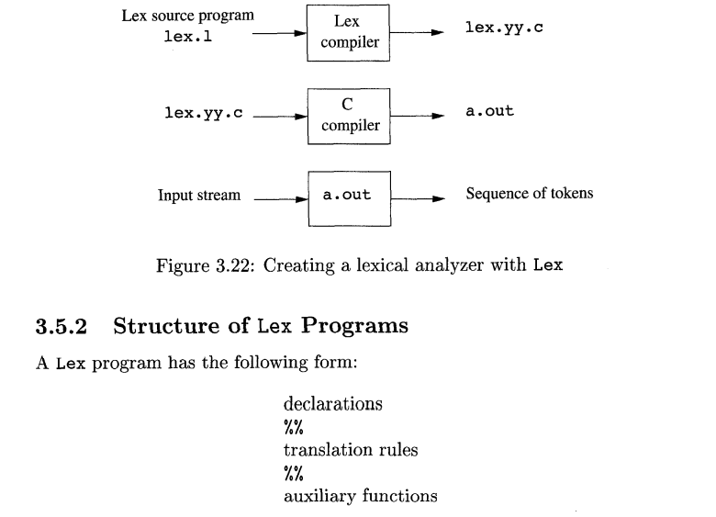

Implementing a Lexical Analyzer (Lexer)
A lexical analyzer (or lexer) is a program that breaks down input text (usually source code) into a sequence of tokens. It reads the input string character by character and identifies the meaningful tokens based on predefined rules, such as keywords, operators, and identifiers.
To implement a lexical analyzer for the given LEX program, we'll follow a step-by-step process.

Given Lex Program:
/* AUXILLARY DEFINITIONS: (none) */

/* TRANSLATION RULES: */

a {}
abb {}
a*b+ {}

Explanation:
- Lexical Analyzer:
  - A lexical analyzer (lexer) takes input text and divides it into tokens, which are meaningful sequences like keywords, operators, identifiers, etc.
  - Each translation rule in the Lex program is associated with a regular expression pattern and an action. If the pattern matches part of the input, the corresponding action is executed.
- Step-by-Step Implementation:
The Lex program consists of three translation rules:
  - a {}: Matches a single occurrence of the character a.
  - abb {}: Matches the exact sequence of characters abb.
  - a*b+ {}: Matches zero or more a characters followed by one or more b characters.

Detailed Breakdown of the Lex Program:

1. Pattern 1: a {}
- This rule matches a single occurrence of the character a.
- The action is empty, meaning that no specific action is taken when this pattern is matched. However, you can add code inside the curly braces to perform an action (e.g., print a message or return a token).

2. Pattern 2: abb {}
- This rule matches the exact string abb.
- Similarly, the action is empty, but you can define what happens when this string is found in the input.

3. Pattern 3: a*b+ {}
- This rule matches zero or more a characters followed by one or more b characters.
- Again, no specific action is defined, but you can add behavior for this match.

How the Lexical Analyzer Works:
- Initialization: The lexical analyzer starts by reading the input string (character by character).
- Matching Patterns: For each input character, it checks which pattern matches:
  - It looks for occurrences of a.
  - It looks for occurrences of the string abb.
  - It looks for a pattern of zero or more a characters followed by one or more b characters.
- Execution of Actions: When a match is found, the associated action (if any) is executed.

Steps to Implement the Lexical Analyzer for this Lex Program:
- Write the Lex Program: The Lex program you provided is already structured. If you'd like to output specific information when each pattern is matched, you can define actions inside the curly braces for each rule.
- Run Lex:
  - Save the program in a file (e.g., lexer.l).
  - Run the Lex tool to generate a C program:
lex lexer.l
This will generate a C file (lex.yy.c), which contains the lexer code.
- Compile the C Program:
  - After generating the C file, compile it using GCC:
gcc lex.yy.c -o lexer -ll
The -ll option tells GCC to link the Lex library.
- Run the Lexical Analyzer:
  - Once compiled, run the lexer:
./lexer
  - The program will read input from standard input (or from a file if redirected) and process it according to the patterns defined.

Example Input and Expected Behavior:
If you enter the string aababbab, the lexer will attempt to match the input with the patterns:
- a will match the first a and perform the associated action.
- abb will match the abb in the input and perform the associated action.
- a*b+ will match the remaining ab and perform the associated action.

No Action Specified:
Since no actions are defined in the original Lex program (curly braces are empty), the lexical analyzer will not output anything or perform any specific actions when it matches a pattern. However, you can modify the Lex program by adding actions to print messages or return tokens as needed.
- Write step by step procedure to construct the NFA for the following regular expression: R= (a | b)*abb
- What is input buffering? How it helps in construction of compiler? Explain.

Input Buffering in Compiler Construction:
Input buffering refers to the technique used to manage and optimize the reading of characters or tokens from the input stream (such as a file or user input) during the compilation process. The main goal of input buffering is to improve the efficiency of the lexical analysis phase of a compiler by minimizing the number of I/O operations required to read the input.

Purpose and Importance of Input Buffering:
During lexical analysis, the input stream is read character by character to identify tokens. This process can be slow if we perform I/O operations for every single character. To mitigate this, input buffering stores multiple characters from the input in a buffer, allowing the lexer (lexical analyzer) to operate on a chunk of data at a time, rather than reading character by character.

How Input Buffering Works:
- Input Stream: The input stream (such as source code from a file) is typically read in small chunks into a buffer. The buffer temporarily holds a sequence of characters that the lexical analyzer can process more efficiently.
- Buffering Mechanism: Input buffering involves dividing the input stream into manageable chunks. There are two common approaches to input buffering:
  - Single Buffering: The entire input is read into a single buffer. The lexical analyzer processes the buffer sequentially. When the buffer is empty, a new chunk of the input is loaded.
  - Double Buffering: Two buffers are used. While one buffer is being processed, the other is being filled with new input data. This allows the lexical analyzer to process the current buffer while simultaneously preparing the next buffer, reducing the wait time between reads.
- Efficient Token Recognition: The lexical analyzer reads characters from the buffer to identify tokens. By reading multiple characters at once, it can minimize the number of I/O operations and reduce latency. After processing a token, the analyzer can move to the next token in the buffer, making the process faster than reading from the input stream character by character.

How Input Buffering Helps in Compiler Construction:
- Improves Performance:
  - Fewer I/O Operations: Since input buffering loads multiple characters at once, the number of I/O operations is significantly reduced. This increases the overall speed of the lexical analysis phase.
  - Reduced Latency: Double buffering allows the lexical analyzer to continue processing while waiting for the next chunk of input, minimizing idle time.
- Efficient Lexical Analysis:
  - Input buffering ensures that the lexical analyzer has enough characters to work with, allowing it to perform more efficient tokenization. The lexical analyzer can read from the buffer and make decisions (e.g., determining keywords, operators, identifiers) without constantly waiting for new data from the input source.
- Prevents Repeated Reads:
  - Without buffering, every time the lexical analyzer needs to read a character, it would require an I/O operation. Input buffering reduces this by reading larger chunks of the input at once, making the process of token recognition faster and more efficient.
- Memory Efficiency:
  - Buffering is typically implemented with a small fixed-size buffer, making it memory efficient. It does not require the entire input to be loaded into memory at once but allows the compiler to work with smaller, manageable portions.

Example of Input Buffering in Action:
Let's assume the input stream is "int x = 5;".
- In single buffering, the input stream is read into a buffer, e.g., a buffer of size 10. The lexical analyzer then processes each character in the buffer. If the buffer runs out, the analyzer loads more data.
- In double buffering, while the lexical analyzer processes one buffer, another buffer is being filled with the next portion of the input. This allows the lexical analyzer to continue working without waiting for new data.

All Answers: Unit – 2:

1. Ans.

In the syntax analysis phase of a compiler, the parser plays a crucial role in ensuring that the tokens generated by the lexical analyzer conform to the syntactic rules of the programming language. Here’s a concise overview of the syntax analysis process and the types of parsers:
The parser plays a crucial role in the syntax analysis phase of a compiler. Its primary responsibilities include:
- Token Verification:
  - The parser checks whether the sequence of tokens generated by the lexical analyzer adheres to the syntactic rules of the programming language.
- Grammar Compliance:
  - It verifies that the token string can be generated by the language's grammar, ensuring that the code follows the correct structure.
- Error Detection:
  - The parser identifies and reports syntax errors in the source code, providing feedback on where and what kind of errors occur.
- Parse Tree Construction:
  - It generates a parse tree (or syntax tree) that represents the hierarchical structure of the token sequence, illustrating the relationship between different components of the code.
- Derivation Process:
  - The parser derives the input string from the grammar using a systematic approach (top-down or bottom-up), translating the linear sequence of tokens into a structured format.
- Intermediate Code Generation:
  - The parse tree produced by the parser serves as a foundation for generating intermediate code, which will be used in subsequent compilation phases.

2. Ans.
The parse tree containing the values of attributes at each node for given input string is called annotated or decorated parse tree.

Features of Annotated Parse Trees
- High level specification
- Hides implementation details
- Explicit order of evaluation is not specified

3. Ans.

Removing the children of the left-hand side non-terminal from the parse tree is called Handle Pruning.

A rightmost derivation in reverse can be obtained by handle pruning.

In compiler design, handle pruning is the technique used to optimise the parsing process of a grammar. In order to replace nonterminal symbols to handle, parsing algorithms apply reduction. In LR parsing handle is a substring of the right side of the production rule. Thus, it can be reduced to nonterminal on the left-side of the rule.

4. Ans.

Context Free Grammar is formal grammar, the syntax or structure of a formal language can be described using context-free grammar (CFG), a type of formal grammar. The grammar has four tuples: (V,T,P,S).

V - It is the collection of variables or non-terminal symbols.
T - It is a set of terminals.
P - It is the production rules that consist of both terminals and non-terminals.
S - It is the starting symbol.
A grammar is said to be the Context-free grammar if every production is in the form of :
G -> (V∪T)*, where G ∊ V

eg. S-> aS

5. Ans.

First of all you are finding FIRST and FOLLOW over the grammar in which you have removed left recursion. Therefore surely if you try to create LL(1) parsing table there won't be any 2 entries as left recursion is removed and grammar is unambiguous.
Grammar[ S->SA|A A->a ] is not LL(1) as left recursion exists. To prove it by constructing LL(1) parsing table you need to find FIRST and FOLLOW on this grammar only without modifying it.
6. Ans.

1. Simple LR (SLR) Parsing
- Description:
  - SLR parsing uses a simple approach where it constructs a parsing table based on the grammar and uses a single lookahead token to make parsing decisions.
- Table Construction:
  - The SLR parsing table is built using the states derived from the items of the grammar and follows a standard set of rules.
- Advantages:
  - Easier to implement than other LR parsing methods.
  - Sufficient for many grammars, especially those without ambiguities or conflicts.
- Disadvantages:
  - Limited power; cannot handle all grammars, particularly those requiring more lookahead to resolve conflicts.

2. Look-Ahead LR (LALR) Parsing
- Description:
  - LALR parsing improves on SLR by using the same states as SLR but combines similar states based on the lookahead symbol.
- Table Construction:
  - The LALR parsing table is constructed by merging states from the SLR parsing table, allowing more context by considering the lookahead token.
- Advantages:
  - More powerful than SLR; can handle a wider range of grammars, including some that produce conflicts in SLR parsing.
  - Efficient in terms of space, as it often results in smaller parsing tables.
- Disadvantages:
  - Still cannot handle all possible conflicts, but it is much more effective than SLR.

3. Canonical LR Parsing
- Description:
  - Canonical LR parsing is the most powerful of the three methods, using a complete set of states derived from the items of the grammar, which include the full context of the grammar.
- Table Construction:
  - The canonical LR parsing table is constructed using all possible states of the grammar, allowing it to handle any context-free grammar with no conflicts.
- Advantages:
  - Can handle the largest class of grammars, including all LR(1) grammars, which are grammars that can be parsed with one lookahead token.
  - Capable of resolving ambiguities and conflicts effectively.
- Disadvantages:
  - More complex to implement than SLR and LALR.
  - Generally results in larger parsing tables, requiring more memory.

Most Powerful Method
Canonical LR parsing is considered the most powerful of the three methods because it can handle the most complex grammars without conflicts. It incorporates a complete set of states derived from the grammar, providing a comprehensive understanding of the syntax being parsed. While SLR and LALR have their advantages in terms of simplicity and efficiency, they are limited in the range of grammars they can process effectively. Canonical LR parsing's ability to resolve conflicts makes it suitable for more complex programming languages, making it the preferred choice in many compiler implementations.

7. Ans.
The given grammar:

E -> E + E
E -> E * E
E -> (E)
E -> id
is ambiguous because expressions can be parsed in multiple ways, especially with operators like + and *, which can lead to different interpretations of the order of operations.

Identify the Ambiguities: The ambiguities in this grammar arise from the lack of clear precedence and associativity rules for the operators.
Introduce Non-terminals for Different Levels of Precedence: We can create separate non-terminals to reflect operator precedence. In this case, multiplication (*) has higher precedence than addition (+).
Define the Grammar with Clear Precedence and Associativity: We'll create a new grammar that respects the precedence and left associativity of the operators.

Revised Grammar :
E -> E + T | T
T -> T * F | F
F -> (E) | id

8. Ans.

Left recursion in a grammar occurs when a non-terminal directly or indirectly references itself as the leftmost symbol in one of its productions. In the given grammar:
E -> E + aT | T

Steps to Remove Left Recursion
- Identify Left Recursive Productions:
  - The left recursive production is E -> E + aT.
- Introduce a New Non-terminal:
  - We will create a new non-terminal to help remove the left recursion. Let's call this new non-terminal E'.
- Reformulate the Productions:
  - The left recursion can be removed by restructuring the productions as follows:
  - The non-recursive part will be moved to the original non-terminal.
  - The recursive part will be placed in the new non-terminal.

Transformed Grammar
The left-recursive grammar can be transformed into a right-recursive grammar like this
E -> T E'
E' -> + aT E' | ε

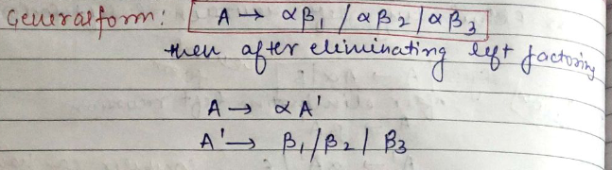
9. Ans.

Following are the various parameters for NFA. Q = { q0, q1, q2 } ? = ( a, b ) F = { q2 }

DFA Table:
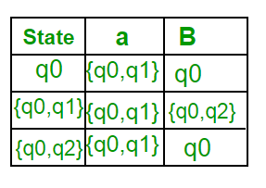

10. Ans.
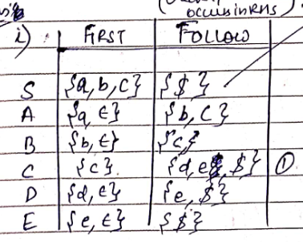
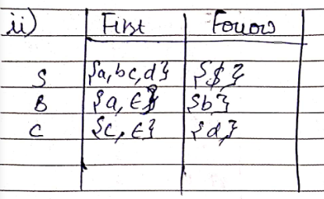

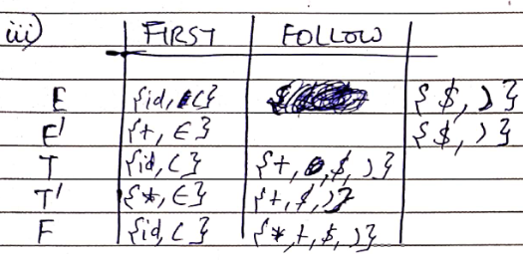

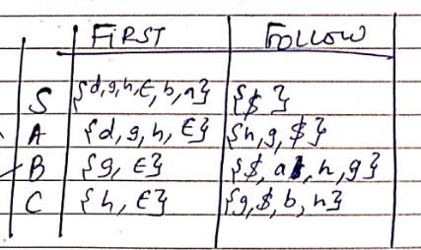
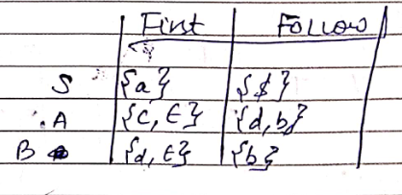

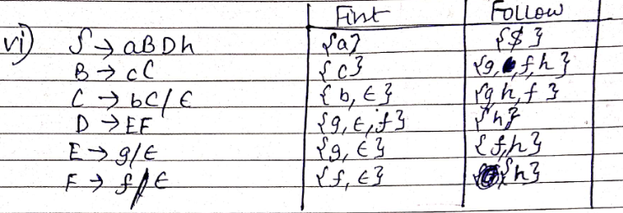

11. Ans.

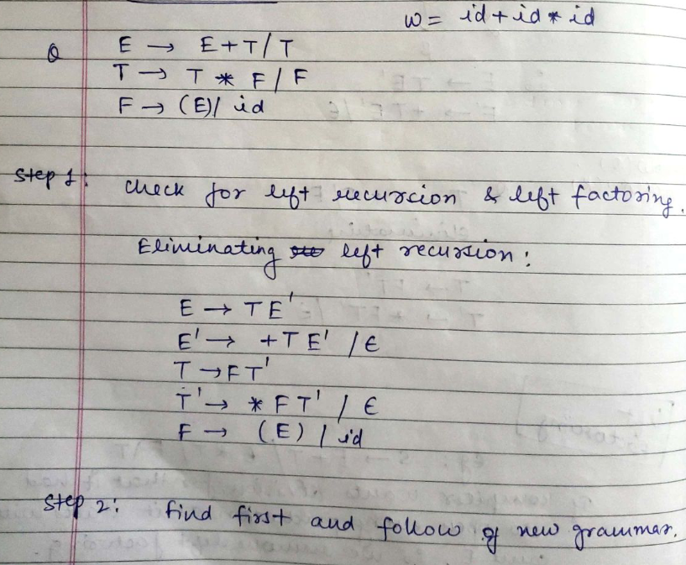

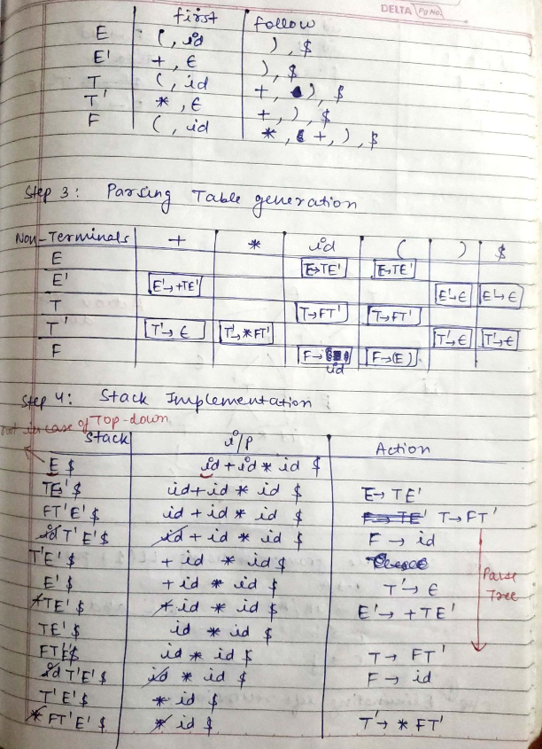

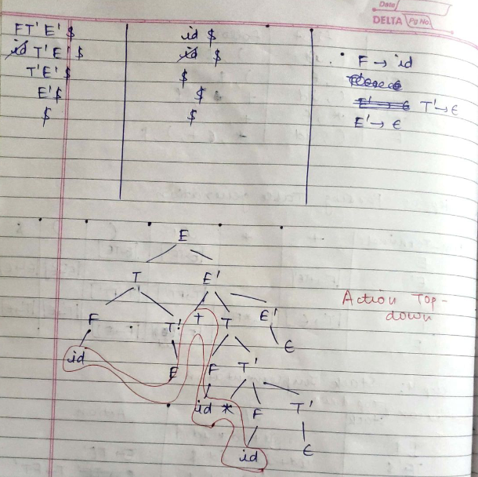

12. Ans.

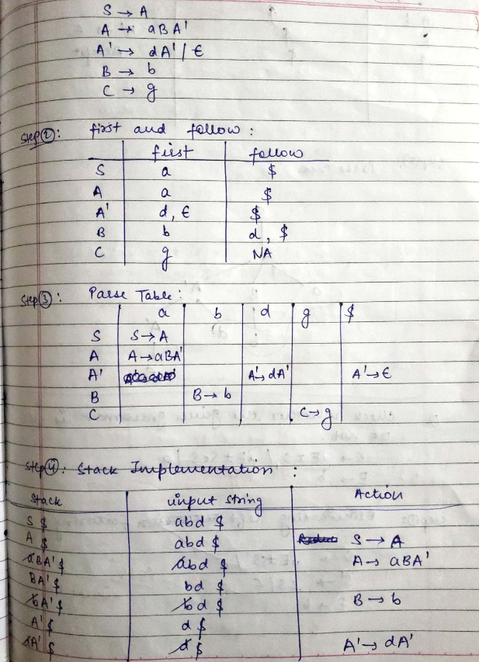

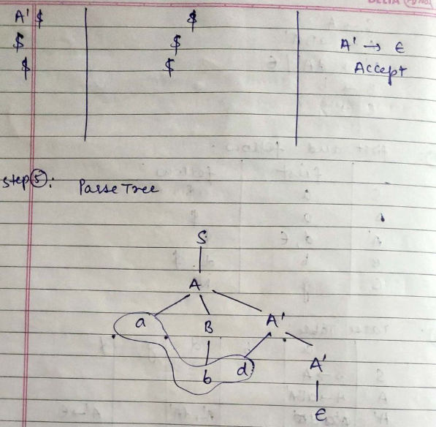
13. Ans.

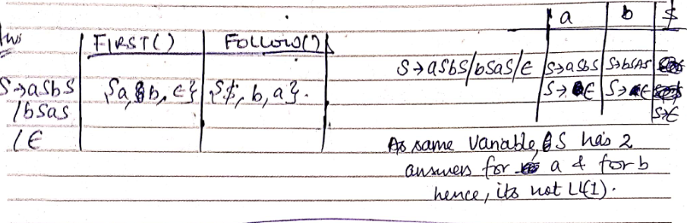

14. Ans.

15. Ans.
16. Ans.

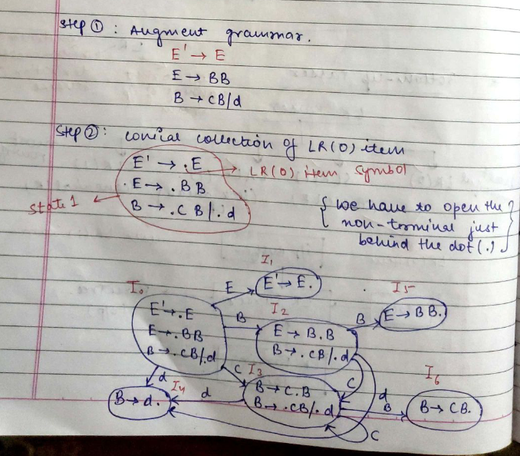

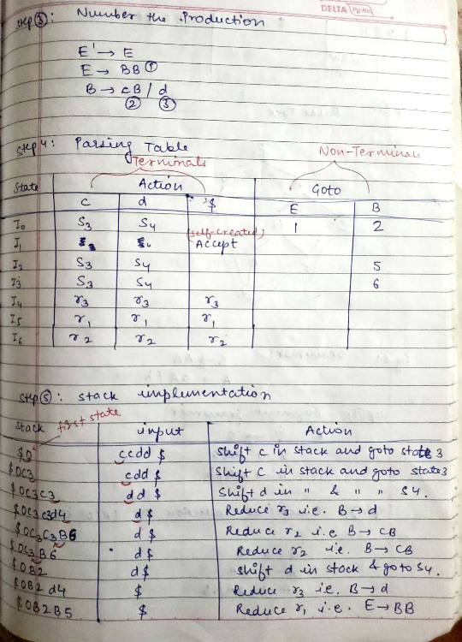

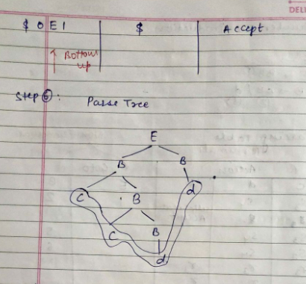

COMPILER DESIGN UNIT – 3 QUESTIONS

Q1. Define Syntax-Directed Definitions.
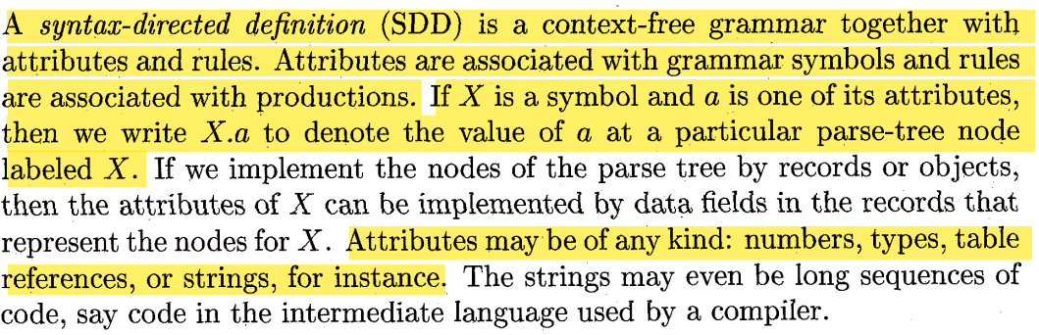
Q2. What are the types of Attributes?
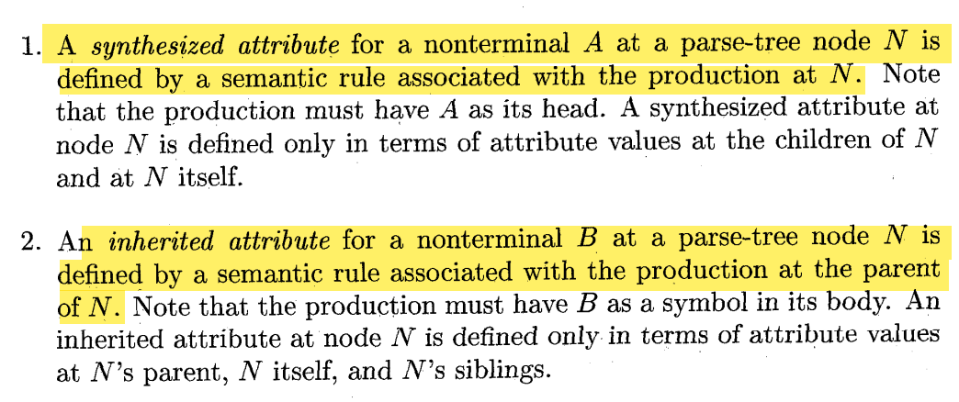
Eg:-
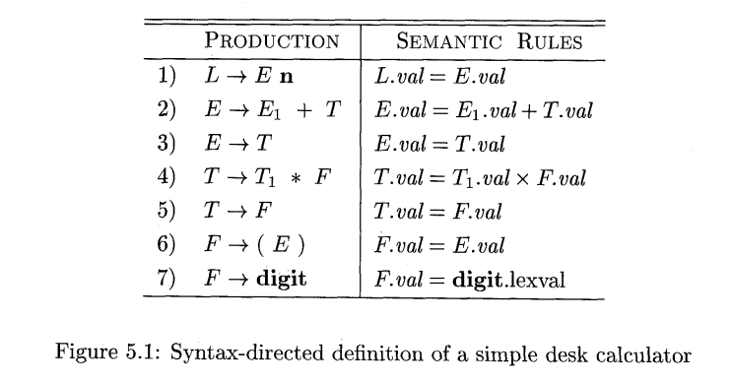
Q3. What is S-attributed SDD?
In an S-attributed SDD, each rule computes an attribute for the nonterminal at the head of a production from attributes taken from the body of the production
Q4. What is attribute grammar?
An SDD without side effects is sometimes called an attribute grammar. The rules in an attribute grammar define the value of an attribute purely in terms of the values of other attributes and constants.
Q5. What is annotated parse-tree?
A parse tree, showing the value(s) of its attribute(s) is called an annotated parse tree.
Q6. How SDD is Evaluated at parse tree notes?
We can evaluate an attribute at a node of a parse tree, we must evaluate all the attributes upon which its value depends. For example, if all attributes are synthesized, as in Example 5.1, then we must evaluate the ual attributes at all of the children of a node before we can evaluate the val attribute at the node itself. With synthesized attributes, we can evaluate attributes in any bottom-up order, such as that of a postorder traversal of the parse tree;
For SDD's with both inherited and synthesized attributes, there is no guarantee that there is even one order in which to evaluate attributes at nodes. For instance, consider nonterminals A and B, with synthesized and inherited attributes A.s and B.i, respectively, along with the production and rules
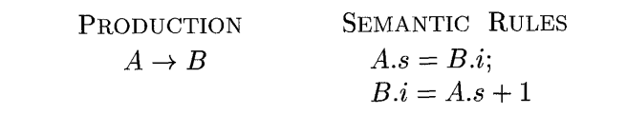
The circular dependency of A.s and B.i at some pair of nodes in a parse tree is suggested by Fig. 5.2. It is computationally difficult to determine whether or not there exist any circularities in any of the parse trees that a given SDD could have to translate.' Fortunately, there are useful subclasses of SDD's that are sufficient to guarantee that an order of evaluation exists.
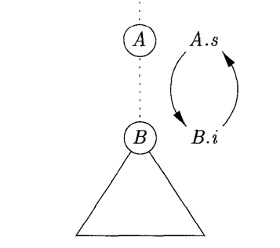

Q7. Give annotated parse-tree for 3*5+4n for simple desk calculator.
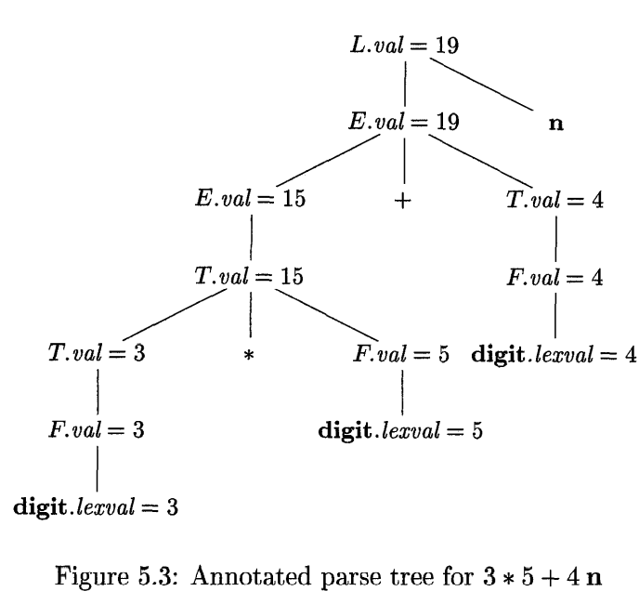

Q8. Give example of top-down parsing on L-attributed SDD.
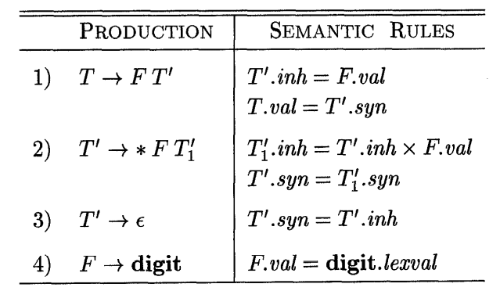

The grammar in this example is an excerpt from a non-left-recursive version of the familiar expression grammar; we used such a grammar as a running example to illustrate top-down parsing.
Each of the nonterminals T and F has a synthesized attribute val; the terminal digit has a synthesized attribute lexval. The nonterminal T' has two attributes: an inherited attribute inh and a synthesized attribute syn.

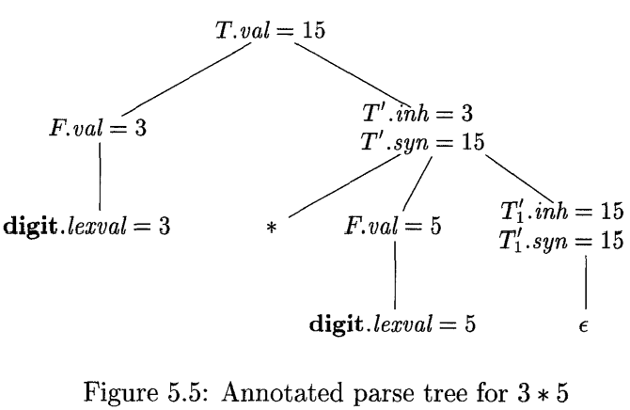

Q9. What is dependency graph?
A dependency graph depicts the flow of information among the attribute instances in a particular parse tree; an edge from one attribute instance to another means that the value of the first is needed to compute the second. Edges express constraints implied by the semantic rules.
Consider the following production and rule:
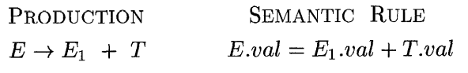

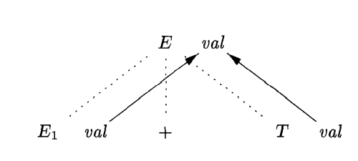

E. val is synthesized from El. val and E2. Val
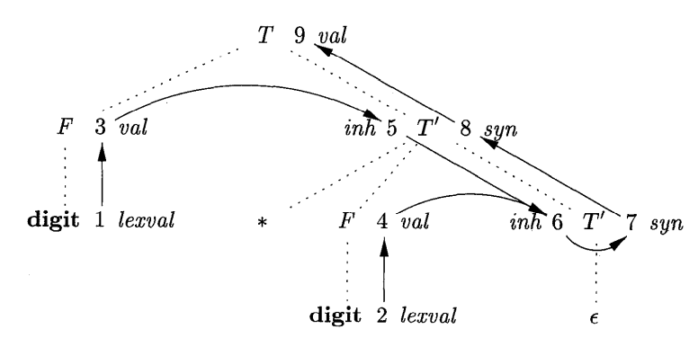

Dependency graph for the annotated parse tree of L-attributed SDD.

Q10. Explain Order of Evaluation of attributes.
The dependency graph characterizes the possible orders in which we can evaluate the attributes at the various nodes of a parse tree. If the dependency graph has an edge from node M to node N, then the attribute corresponding to M must be evaluated before the attribute of N. Thus, the only allowable orders of evaluation are those sequences of nodes Nl, N2,. . . , Nk such that if there is an edge of the dependency graph from Ni to Nj; then i < j. Such an ordering embeds a directed graph into a linear order, and is called a topological sort of the graph.
If there is any cycle in the graph, then there are no topological sorts; that is, there is no way to evaluate the SDD on this parse tree. If there are no cycles, however, then there is always at least one topological sort
Q11. Give Definition of S-attributed SDD.
The first class is defined as follows:
A SDD is S-attributed if every attribute is synthesized.
When an SDD is S-attributed, we can evaluate its attributes in ahy bottomup order of the nodes of the parse tree. It is often especially simple to evaluate the attributes by performing a postorder traversal of the parse tree and evaluating the attributes at a node N when the traversal leaves N for the last time. That is, we apply the function postorder, defined below, to the root of the parse tree
postorder (N) {
for (each child C of N, from the left) postorder(C);
evaluate the attributes associated with node N;
}
S-attributed definitions can be implemented during bottom-up parsing, since a bottom-up parse corresponds to a postorder traversal. Specifically, postorder corresponds exactly to the order in which an LR parser reduces a production body to its head.
Q12. Give Definition of L-attributed SDD.
The second class of SDD's is called L-attributed definitions. The idea behind this class is that, between the attributes associated with a production body, dependency-graph edges can go from left to right, but not from right to left (hence "L-attributed"). More precisely, each attribute must be either
- Synthesized, or
- Inherited, but with the rules limited as follows. Suppose that there is a production A -> X1X2 - - Xn, and that there is an inherited attribute Xi.a computed by a rule associated with this production. Then the rule may use only:
- Inherited attributes associated with the head A
- Either inherited or synthesized attributes associated with the occurrences of symbols X1, X2,. . . , Xi-l located to the left of Xi.
- Inherited or synthesized attributes associated with this occurrence of Xi itself, but only in such a way that there are no cycles in a dependency graph formed by the attributes of this Xi.
Eg:-
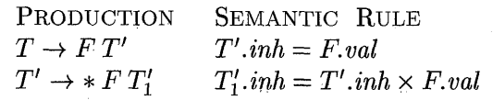

The first of these rules defines the inherited attribute Tf.inh using only F.ual, and F appears to the left of TI in the production body, as required. The second rule defines Ti.inh using the inherited attribute T1.inh associated with the head, and F.va1, where F appears to the left of T,' in the production body. In each of these cases, the rules use information "from above or from the left ," as required by the class. The remaining attributes are synthesized. Hence, the SDD is L-attributed.
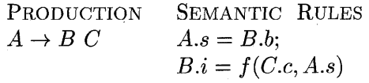

The second rule defines an inherited attribute B.i, so the entire SDD cannot be S-attributed. Further, although the rule is legal, the SDD cannot be Lattributed, because the attribute C.c is used to help define B.i, and C is to the right of B in the production body.
Q13. What are Semantic Rules with controlled side effect?
In practice, translations involve side effects: a desk calculator might print a result; a code generator might enter the type of an identifier into a symbol table. With SDD's, we strike a balance between attribute grammars and translation schemes. Attribute grammars have no side effects and allow any evaluation order consistent with the dependency graph. Translation schemes impose left-to-right evaluation and allow semantic actions to contain any program fragment.
We shall control side effects in SDD's in ope of the following ways:
- Permit incidental side effects that do not constrain attribute evaluation. In other words, permit side effects when attribute evaluation based on any topological sort of the dependency graph produces a "correct" translation, where "correcti7 depends on the application
- Constrain the allowable evaluation orders, so that the same translation is produced for any allowable order. The constraints can be thought of as implicit edges added to the dependency graph.
As an example of an incidental side effect, let us modify the desk calculator of Example 5.1 to print a result. Instead of the rule L.val= E.val, which saves the result in the synthesized attribute L. val, consider:
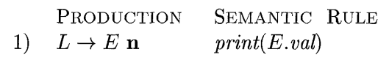

Semantic rules that are executed for their side effects, such as print(E.val), will be treated as the definitions of dummy synthesized attributes associated with the head of the production. The modified SDD produces the same translation under any topological sort, since the print statement is executed at the end, after the result is computed into E.val.
Q14. Explain the construction of Syntax tree.
As discussed in Section 2.8.2, each node in a syntax tree represents a construct; the children of the node represent the meaningful components of the construct. A syntax-tree node representing an expression El + Ez has label + and two children representing the subexpressions El and E2.
We shall implement the nodes of a syntax tree by objects with a suitable number of fields. Each object will have an op field that is the label of the node. The objects will have additional fields as follows:
- If the node is a leaf, an additional field holds the lexical value for the leaf. A constructor function Leaf ( op, val) creates a leaf object
- If the node is an interior node, there are as many additional fields as the node has children in the syntax tree.

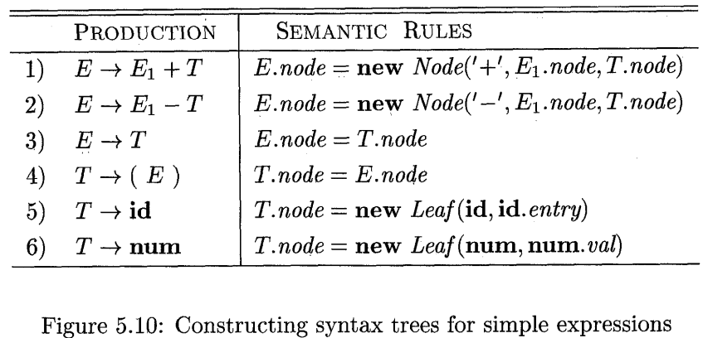
Every time the first production E -+ El + T is used, its rule creates a node with '+I for op and two children, El.node and T.node, for the subexpressions. The second production has a similar rule
The last two T-productions have a single terminal on the right. We use the constructor Leaf to create a suitable node, which becomes the value of T.node.
For production 3, E -+ T, no node is created, since E.node is the same as T.node. Similarly, no node is created for production 4, T --+ ( E )
The nodes of the syntax tree are shown as records, with the op field first. Syntax-tree edges are now shown as solid lines. The underlying parse tree, which need not actually be constructed, is shown with dotted edges. The third type of line, shown dashed, represents the values of E.node and T.node; each line points to the appropriate syntax-tree node.

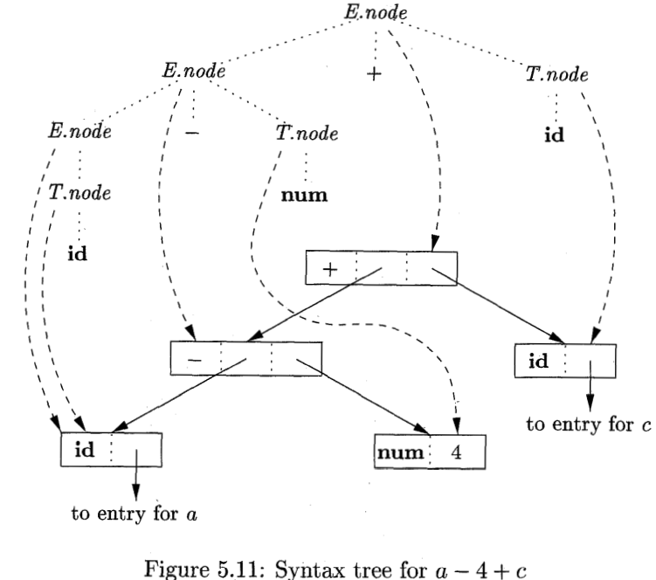
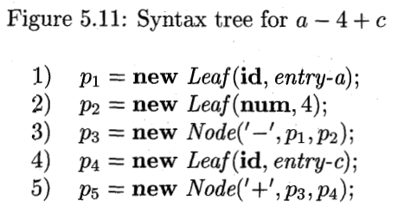

The rules for building syntax trees in this example are similar to the rules for the desk calculator in Example 5.3. In the desk-calculator example, a term x * y was evaluated by passing x as an inherited attribute, since x and * y appeared in different portions of the parse tree. Here, the idea is to build a syntax tree for x + y by passing x as an inherited attribute, since x and + y appear in different subtrees.
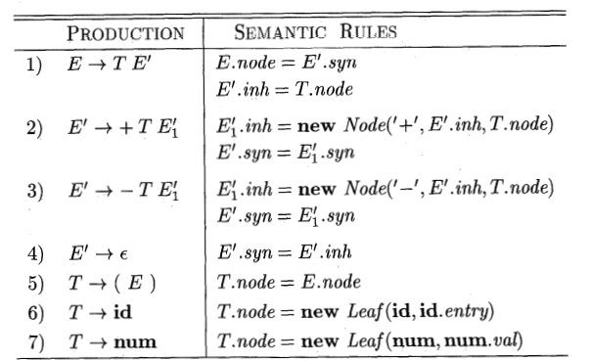

Constructing syntax trees during top-down parsing with L-attributed SDD.

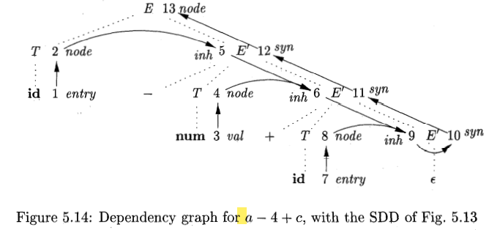
Q15. What are Syntax-Directed Translation Schemes (SDT)?
Syntax-directed translation schemes are a complementary notation to syntax directed definitions. All of the applications of syntax-directed definitions in Section 5.3 can be implemented using syntax-directed translation schemes.
A syntax-directed translation scheme (SDT) is a context free grammar with program fragments embedded within production bodies. The program fragments are called semantic actions and can appear at any position within a production body. By convention, we place curly braces around actions; if braces are needed as grammar symbols, then we quote them.
Typically, SDT's are implemented during parsing, without building a parse tree. In this section, we focus on the use of SDT's to implement two important classes of SDDs:
- The underlying grammar is LR-parsable, and the SDD is S-attributed.
- The underlying grammar is LL-parsable, and the SDD is L-attributed.
We shall see how, in both these cases, the semantic rules in an SDD can be converted into an SDT with actions that are executed at the right time. During parsing, an action in a production body is executed as soon as all the grammar symbols to the left of the action have been matched.
Q16. What are Postfix Translation Schemes?
By far the simplest SDD implementation occurs when we can parse the grammar bottom-up and the SDD is S-attributed. In that case, we can construct an SDT in which each action is placed at the end of the production and is executed along with the reduction of the body to the head of that production. SDT's with all actions at the right ends of the production bodies are called postfix SDT's.
The postfix SDT in Fig. 5.18 implements the desk calculator SDD of Fig. 5.1, with one change: the action for the first production prints a value. The remaining actions are exact counterparts of the semantic rules. Since the underlying grammar is LR, and the SDD is S-attributed, these actions can be correctly performed along with the reduction steps of the parser.
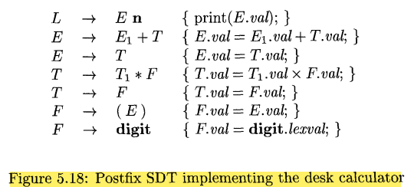

Q17. What is Parser-Stack Implementation of postfix SDT?
Postfix SDT's can be implemented during LR parsing by executing the actions when reductions occur. The attribute(s) of each grammar symbol can be put on the stack in a place where they can be found during the reduction. The best plan is to place the attributes along with the grammar symbols (or the LR states that represent these symbols) in records on the stack itself.
The parser stack contains records with a field for a grammar symbol (or parser state) and, below it, a field for an attribute. The three grammar symbols X YZ are on top of the stack; perhaps they are about to be reduced according to a production like A -+ X YZ. Here, we show X.x as the one attribute of X, and so on.
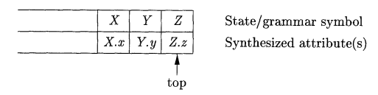
Parser stack with a field for synthesized attributes
If the attributes are all synthesized, and the actions occur at the ends of the productions, then we can compute the attributes for the head when we reduce the body to the head. If we reduce by a production such as A -+ X YZ, then we have all the attributes of X, Y, and Z available, at known positions on the stack, as in Fig. 5.19. After the action, A and its attributes are at the top of the stack, in the position of the record for X.
Suppose that the stack is kept in an array of records called stack, with top a cursor to the top of the stack. Thus, stack[top] refers to the top record on the stack, stack[top - 1] to the record below that, and so on. Also, we assume that each record has a field called val, which holds the attribute of whatever grammar symbol is represented in that record. Thus, we may refer to the attribute E.va1 that appears at the third position on the stack as stack[top - 2} .Val.
For instance, in the second production, E + El + T, we go two positions below the top to get the value of El, and we find the value of T at the top. The resulting sum is placed where the head E will appear after the reduction, that is, two positions below the current top. The reason is that after the reduction, the three topmost stack symbols are replaced by one. After computing E.val, we pop two symbols off the top of the stack, so the record where we placed E.val will now be at the top of the stack.
The same observation applies to the productions T -+ F and F -+ digit. Production F + ( E ) is slightly different. Although the value does not change, two positions are removed from the stack during the reduction, so the value has to move to the position after the reduction.
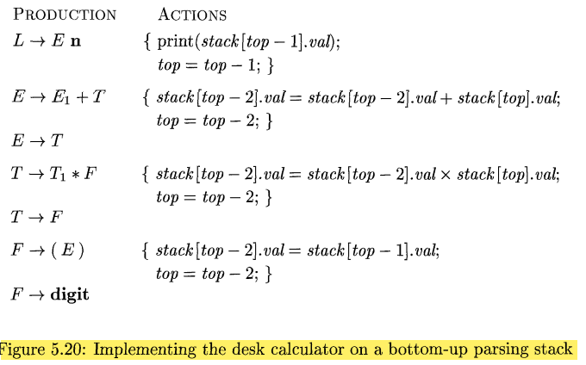
Q18. Explain with SDT’s with Actions Inside Production.
An action may be placed at any position within the body of a production. It is performed immediately after all symbols to its left are processed. Thus, if we have a production B -+ X {a} Y, the action a is done after we have recognized X (if X is a terminal) or all the terminals derived from X (if X is a nonterminal) . More precisely,
- If the parse is bottom-up, then we perform action a as soon as this occurrence of X appears on the top of the parsing stack.
- If the parse is top-down, we perform a just before we attempt to expand this occurrence of Y (if Y a nonterminal) or check for Y on the input (if Y is a terminal).
SDT's that can be implemented during parsing include postfix SDT's and a class of SDT's considered in Section 5.5 that implements L-attributed definitions. Not all SDT's can be implemented during parsing, as we shall see in the next example.
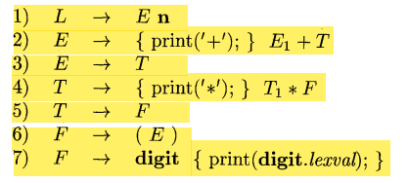

As an extreme example of a problematic SDT, suppose that we turn our desk-calculator running example into an SDT that prints the prefix form of an expression, rather than evaluating the expression.
Unfortunately, it is impossible to implement this SDT during either topdown or bottom-up parsing, because the parser would have to perform critical actions, like printing instances of * or +, long before it knows whether these symbols will appear in its input.
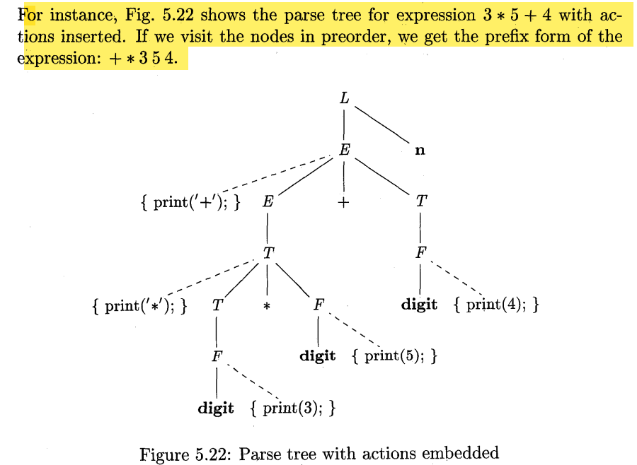
Q19. What is Intermediate code generation?
Intermediate code generation is a phase in a compiler's design where the source program is translated into an intermediate representation (IR) that is independent of both the source language and the target machine. This IR acts as a bridge between the front end (which analyzes the source code) and the back end (which generates target code). By using an IR, the development of compilers becomes modular and flexible.
Representation:
- High-Level IR: Close to the source language, suitable for tasks like type checking (e.g., syntax trees).
- Low-Level IR: Close to machine code, used for tasks like register allocation (e.g., three-address code).
Three-Address Code: A common IR format with instructions like x = y op z, where:
x: Result variable.
y, z: Operand variables.
Example: t1 = a + b.
Advantages:
- Modularity: Decouples source language analysis from target machine specifics.
- Optimization: Enables language-independent and machine-independent optimizations.
- Portability: Simplifies the process of supporting new languages or architectures.
Static Checking:
Ensures type compatibility and correctness of constructs like break in control structures.
Q20 What is directed acyclic graph (DAG)?
Nodes in a syntax tree represent constructs in the source program; the children of a node represent the meaningful components of a construct. A directed acyclic graph (hereafter called a DAG) for an expression identifies the common sub-expressions (sub-expressions that occur more than once) of the expression.
Q21. What is the difference between DAG and Syntax Tree?
Like the syntax tree for an expression, a DAG has leaves corresponding to atomic operands and interior codes corresponding to operators. The difference is that a node N in a DAG has more than one parent if N represents a common subexpression; in a syntax tree, the tree for the common subexpression would be replicated as many times as the subexpression appears in the original expression
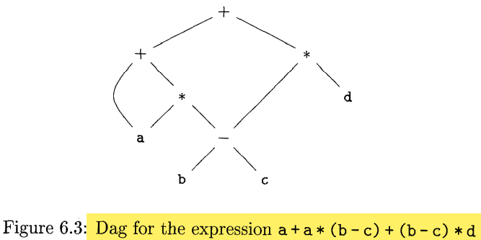
The SDD of Fig. 6.4 can construct either syntax trees or DAG's. It was used to construct syntax trees in Example 5.11, where functions Leaf and Node created a fresh node each time they were called. It will construct a DAG if, before creating a new node, these functions first check whether an identical node already exists. If a previously created identical node exists, the existing node is returned. For instance, before constructing a new node, Node(op, ZeJt, right) we check whether there is already a node with label op, and children left and right, in that order. If so, Node returns the existing node; otherwise, it creates a new node

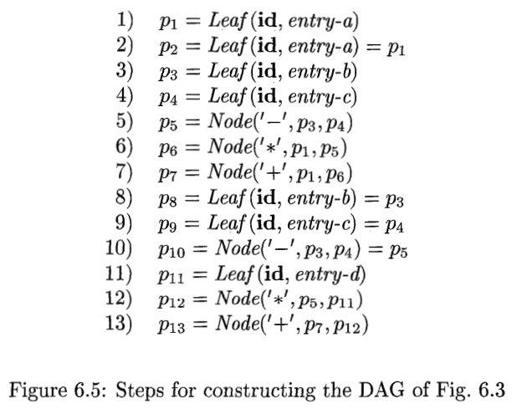

Q22. What is Value-Number Method for Constructing DAG?
Often, the nodes of a syntax tree or DAG are stored in an array of records, as suggested by Fig. 6.6. Each row of the array represents one record, and therefore one node. In each record, the first field is an operation code, indicating the label of the node. In Fig. 6.6(b), leaves have one additional field, which holds the lexical value (either a symbol-table pointer or a constant, in this case), and interior nodes have two additional fields indicating the left and right children. D
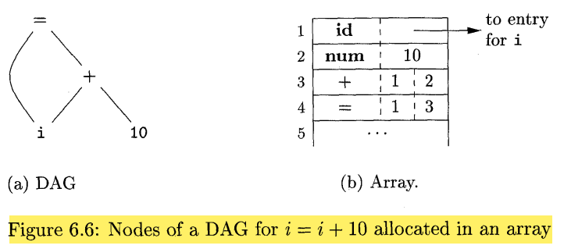

Q23. What is Three-address Code?
In three-address code, there is at most one operator on the right side of an instruction; that is, no built-up arithmetic expressions are permitted. Thus a source-language expression like x+y*z might be translated into the sequence of t hree-address instructions.
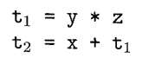

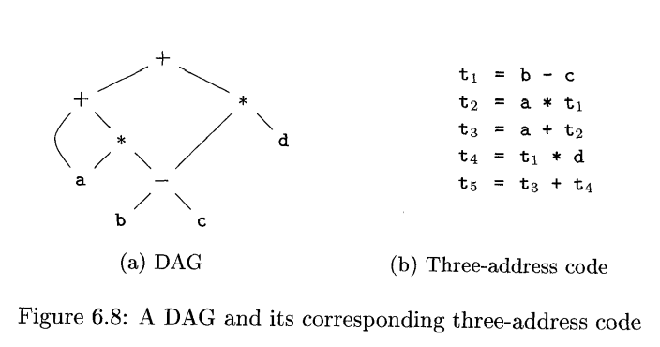

Q24. What are Addresses in Three-address Code?
Three-address code is built from two concepts: addresses and instructions. In object-oriented terms, these concepts correspond to classes, and the various kinds of addresses and instructions correspond to appropriate subclasses. Alternatively, three-address code can be implemented using records with fields for the addresses; records called quadruples and triples.
An address can be one of the following
- A name. For convenience, we allow source-program names to appear as addresses in three-address code
- A constant. In practice, a compiler must deal with many different types of constants and variables
- A compiler-generated temporary. It is useful, especially in optimizing compilers, to create a distinct name each time a temporary is needed.
Q25. What are Instructions In Three-address Code?

Instructions in Three-Address Code:
Three-address code (TAC) consists of instructions that use at most three addresses (variables, constants, or temporaries). These instructions represent operations and control flow in a way that is intermediate between high-level languages and machine code.

Common Forms of TAC Instructions:
- Binary Operation Assignment:
  - Format: x = y op z
  - Performs a binary arithmetic or logical operation (e.g., addition, subtraction, AND, OR).
  - Example: t1 = a + b.
- Unary Operation Assignment:
  - Format: x = op y
  - Performs unary operations like negation, bitwise complement, or type conversion.
  - Example: t2 = -a.
- Copy Instruction:
  - Format: x = y
  - Copies the value of y into x.
  - Example: t3 = a.
- Unconditional Jump:
  - Format: goto L
  - Transfers control to the instruction labeled L.
  - Example: goto Label1.
- Conditional Jumps:
  - Format: if x goto L or ifFalse x goto L
  - Executes the instruction at L if x is true or false, respectively.
  - Example: if a > b goto Label2.
- Relational Conditional Jump:
  - Format: if x relop y goto L
  - Applies a relational operator (e.g., <, >=, ==) to x and y and jumps to L if the condition is true.
  - Example: if a <= b goto Label3.
- Procedure Calls and Returns:
  - Instructions include:
    - param x: Passes parameter x.
    - call p, n: Calls procedure p with n parameters.
    - y = call p, n: Calls a function p with n parameters, storing the result in y.
    - return y: Returns y (optional).
  - Example: param a; call func, 1.
- Indexed Copy:
  - Format: x = y [i] or x [i] = y
  - Accesses or assigns values using an index offset.
  - Example: t1 = arr[i].
- Address and Pointer Operations:
  - Instructions include:
    - x = &y: Stores the address of y in x.
    - x = *y: Dereferences pointer y to get the value into x.
    - *x = y: Assigns y to the location pointed to by x.
  - Example: t4 = &a.
These instructions are concise yet expressive enough to represent complex operations and control flows, forming a foundation for further optimization and machine-code generation.

Eg.
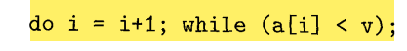
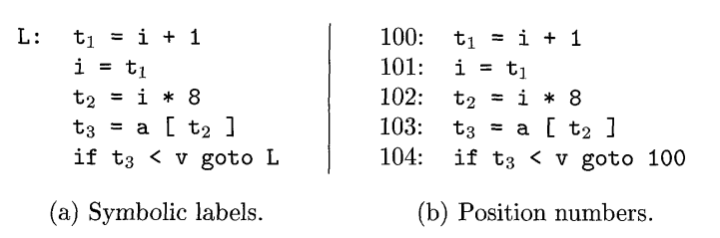
Q26. What are Quadruples?
In a compiler, these instructions can be implemented as objects or as records with fields for the operator and the operands. Three such representations are called "quadruples," triples," and "indirect triples." A quadruple (or just "quad') has four fields, which we call op, arg,, arg2, and result. The op field contains an internal code for the operator. For instance, the three-address instruction x = y +x is represented by placing + in op, y in arg,, 2 in argz, and x in result. The following are some exceptions to this rule:
- Instructions with unary operators like x = minusy or x = y do not use arg,. Note that for a copy statement like x = y, op is =, while for most other operations, the assignment operator is implied.
- Operators like param use neither arg2 nor result.
- Conditional and unconditional jumps put the target label in result.
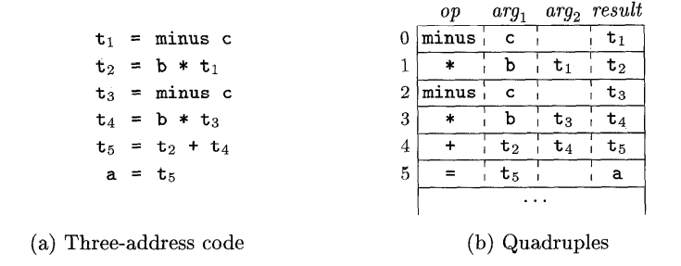
Q27. What are Triples?
A triple has only three fields, which we call op, arg,, and arg2. Note that the result field in Fig. 6.10(b) is used primarily for temporary names. Using triples, we refer to the result of an operation x op y by its position, rather than by an explicit temporary name. Thus, instead of the temporary tl in Fig. 6.10 (b) , a triple representation would refer to position (0). Parenthesized numbers represent pointers into the triple structure itself
Triples are equivalent to signatures in Algorithm 6.3. Hence, the DAG and triple representations of expressions are equivalent. The equivalence ends with expressions, since syntax-tree variants and three-address code represent control flow quite differently.
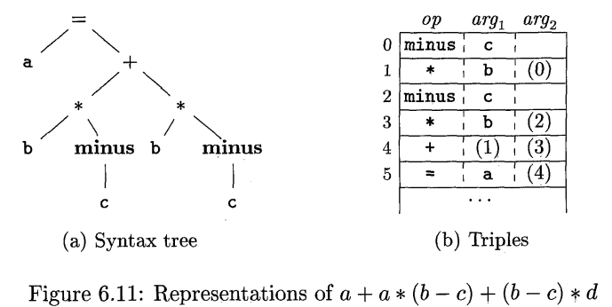

Q28. What are the benefits of using quadruple over triplets?
A benefit of quadruples over triples can be seen in an optimizing compiler, where instructions are often moved around. With quadruples, if we move an instruction that computes a temporary t, then the instructions that use t require no change. With triples, the result of an operation is referred to by its position, so moving an instruction may require us to change all references to that result. This problem does not occur with indirect triples, which we consider next.
Q29. What are Indirect Triples?
With indirect triples, an optimizing compiler can move an instruction by reordering the instruction list, without affecting the triples themselves. When implemented in Java, an array of instruction objects is analogous to an indirect triple representation, since Java treats the array elements as references to objects.
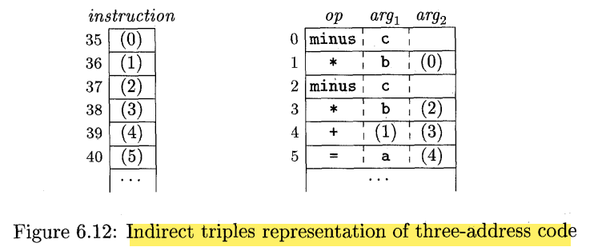

Q30. What is Static Single- Assignment Form?
Statjc single-assignment form (SSA) is an intermediate representation that facilitates certain code optimizations. Two distinctive aspects distinguish SSA from three-address code. The first is that all assignments in SSA are to variables with distinct names; hence the term static single-assigrnent. Figure 6.13 shows the same intermediate program in three-address code and in static singleassignment form. Note that subscripts distinguish each definition of variables p and q in the SSA representation
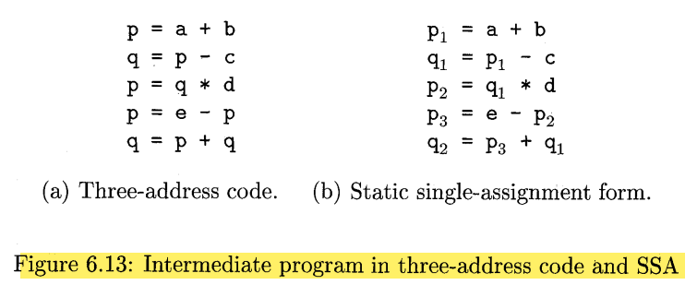

The same variable may be defined in two different control-flow paths in a program. For example, the source program
if ( flag ) x = -1; else x = 1;
y=x*a;
Q31. What are the applications of types can be grouped under checking and translation?
- Type checking uses logical rules to reason about the behavior of a program at run time. Specifically, it ensures that the types of the operands match the type expected by an operator. For example, the && operator in Java expects its two operands to be booleans; the result is also of type boolean.
- Translation Applications. From the type of a name, a compiler can determine the storage that will be needed for that name at run time. Type information is also needed to calculate the address denoted by an array reference, to insert explicit type conversions, and to choose the right version of an arithmetic operator, among other things.
Q32. What are Type Expressions?
Types have structure, which we shall represent using type expressions: a type expression is either a basic type or is formed by applying an operator called a type constructor to a type expression. The sets of basic types and constructors depend on the language to be checked.
The array type int [2] [3] can be read as "array of 2 arrays of 3 integers each" and written as a type expression array(2, array(3, integer)). This type is represented by the tree in Fig. 6.14. The operator array takes two parameters, a number and a type.
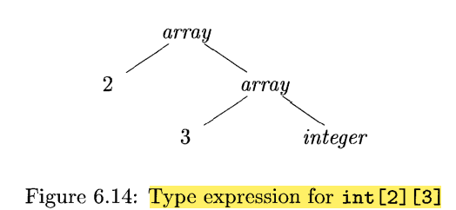

We shall use the following definition of type expressions:
- A basic type is a type expression. Typical basic types for a language include boolean, char, integer, float, and void; the latter denotes "the absence of a value."
- A type name is a type expression.
- A type expression can be formed by applying the array type constructor to a number and a type expression.
- A record is a data structure with named fields. A type expression can be formed by applying the record type constructor to the field names and their types.
- A type expression can be formed by using the type constructor 3 for function types. We write s 3 t for "function from type s to type t."
- If s and t are type expressions, then their Cartesian product s x t is a type expression.
- Type expressions may contain variables whose values are type expressions. Compiler-generated type variables will be used.
Q33. What is Type Equivalence?
When type expressions are represented by graphs, two types are structurally equivalent if and only if one of the following conditions is true:
- They are the same basic type.
- They are formed by applying the same constructor to structurally equivalent types
- One is a type name that denotes the other
Q34. What is Declaration?
Declaration:
A declaration specifies the type and layout of variables and other entities in a program. Using the given grammar:
- D produces a sequence of declarations (Tid;D or a type declaration c).
- T represents a type, which can be a basic type (B), an array type (B C), or a record (record ( D )).
- B specifies basic types like int or float.
- C defines array dimensions using integers within brackets.
This approach links declarations to storage layout, including basic, array, or record types, by describing their structure and placement in memory.
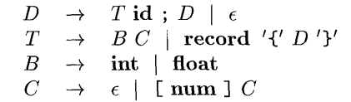

Q35. Explain Storage Layout for Local Names.
From the type of a name, we can determine the amount of storage that will be needed for the name at run time. At compile time, we can use these amounts to assign each name a relative address. The type and relative address are saved in the symbol-table entry for the name. Data of varying length, such as strings, or data whose size cannot be determined until run time, such as dynamic arrays, is handled by reserving a known fixed amount of storage for a pointer to the data.
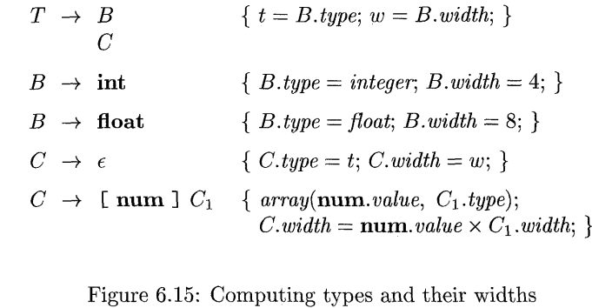

Q36. Explain Sequence of Declaration.
Languages such as C and Java allow all the declarations in a single procedure to be processed as a group. The declarations may be distributed within a Java procedure, but they can still be processed when the procedure is analyzed. Therefore, we can use a variable, say ofset, to keep track of the next available relative address. The translation scheme of Fig. 6.17 deals with a sequence of declarations of the form T id, where T generates a type as in Fig. 6.15. Before the first declaration is considered, offset is set to 0
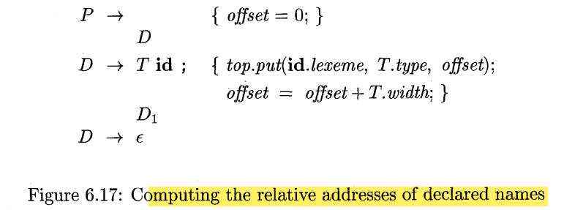
Q37. What are Fields in Records and Classes?
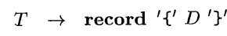

The fields in this record type are specified by the sequence of declarations generated by D. The approach of Fig. 6.17 can be used to determine the types and relative addresses of fields, provided we are careful about two things:
- The field names within a record must be distinct; that is, a name may appear at most once in the declarations generated by D.
- The offset or relative address for a field name is relative to the data area for that record.
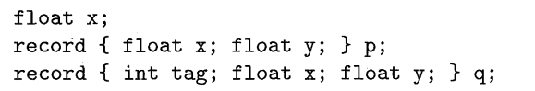

Q38. What are Translation of Expressions?
Translating expressions into three-address code involves breaking down complex expressions into simpler instructions, each containing at most one operator. For instance, a + b * c becomes a sequence of instructions that handle one operation at a time. Similarly, array references like A[i][j] expand into multiple instructions to compute the memory address for the reference. This process ensures clear, step-by-step computation suitable for further compiler phases.

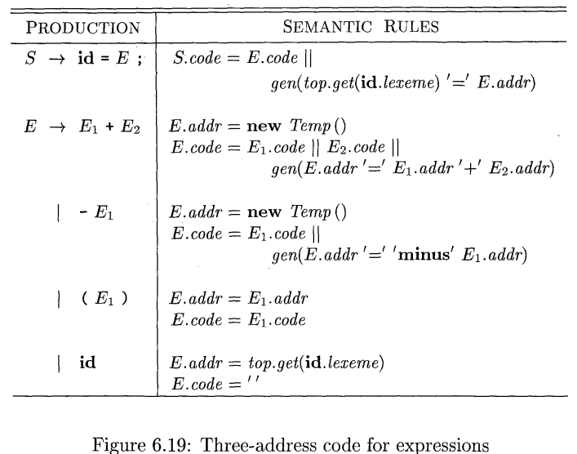

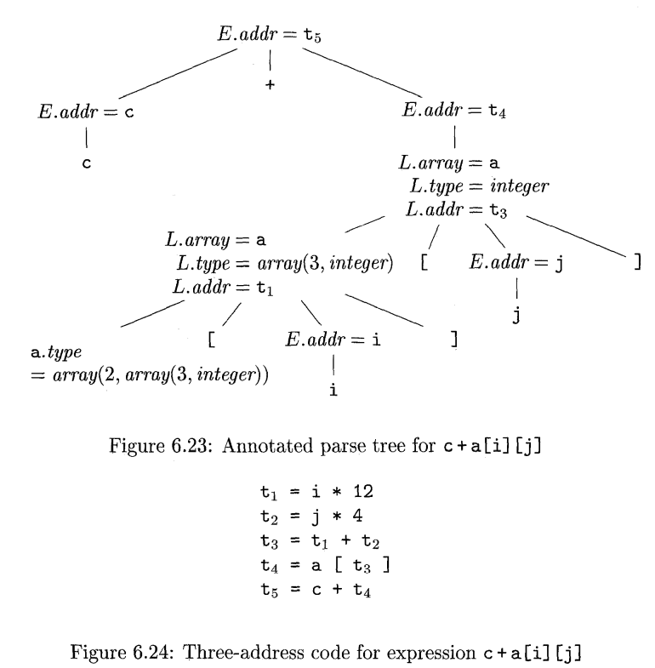
Types of Expression Translation:
- Arithmetic Expressions: Translated into a sequence of three-address instructions for operations like addition, subtraction, multiplication, etc.
Example: a + b * c →
t1 = b * c
t2 = a + t1
- Relational Expressions: Translated into conditional or unconditional jump instructions based on comparison operators like <, >, ==.
Example: if a > b →
if a > b goto L1
- Boolean Expressions: Used to control program flow, translated into jumps and labels. Logical operators (AND, OR, NOT) are handled using control flow.
Example: (a && b) →
ifFalse a goto L2
ifFalse b goto L2
goto L1
- Array References: Expressions like A[i][j] are expanded to compute the address based on array dimensions and indices.
Example: A[i][j] →
t1 = i * row_size
t2 = t1 + j
t3 = base_address + t2
- Pointer Expressions: Involve dereferencing and address computation.
Example: *p = q →
t1 = *p
t1 = q
Q39. What is Type Checking?
Type Checking ensures that the types of program components are consistent with the rules of the programming language. The compiler assigns a type expression to each component and verifies their compatibility. This process helps detect errors early, during compilation, rather than at runtime. A sound type system eliminates runtime type error checks by proving statically that they won't occur. If a compiler guarantees type safety, the language implementation is considered strongly typed.
Q40. What are the Rules for Type Checking?
Rules for Type Checking can be categorized into synthesis and inference:
- Type Synthesis: In type synthesis, the type of an expression is determined based on the types of its subexpressions. The types of individual components are built up into the overall type of the expression. For example, in the case of the expression E1 + E2, the type of the result depends on the types of E1 and E2. A typical synthesis rule might be:
  - If f has type s -> t and x has type s, then f(x) has type t.
- Type Inference: In type inference, the type of an expression is deduced from its usage. It doesn't require explicit declarations for types but instead derives the type based on the context. For example, when calling null(x), the inference system determines that x must be a list, but the type of the elements within the list is not specified at that point, so it remains unknown.
Q41. How does Type Conversions Take place?
Type Conversion occurs when operands of different types are involved in an operation. In such cases, the compiler may need to convert one of the operands to ensure both operands are of the same type. This is typically done through implicit or explicit type conversions, ensuring compatibility for operations.
For example, if x is of type float and i is of type integer in an expression like x + i, the compiler may convert the integer i to a float before performing the addition. Here's how the conversion works:
- Unary Type Conversion: If needed, an operand is converted to a compatible type using a unary operator. In the example of 2 * 3.14, the integer 2 is first converted to a float:
  - t1 = (float) 2
  - t2 = t1 * 3.14
- Operator Overloading: There can be different versions of operators for integers and floats. For example, int* for integer multiplication and float* for floating-point multiplication. This allows the compiler to choose the correct operation based on the operand types.
- Type Synthesis: In type synthesis, the type of an expression is determined based on the types of its subexpressions. When converting operands for an operation like E1 + E2, the compiler ensures both operands have the same type (either both integer or both float) before applying the operator. The rule for this could be:
  - If E1.type is int and E2.type is float, then E1 is converted to float, and the result is computed using the float version of the operator.
Type conversions are essential for ensuring that operations are performed correctly based on operand types, especially in mixed-type expressions like integer and floating-point operations.

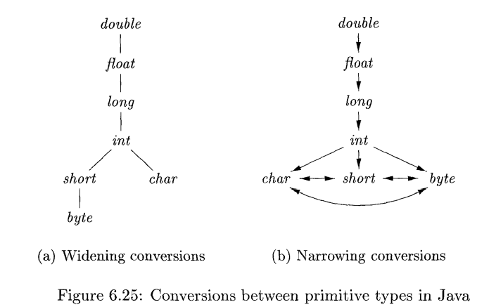

Q42. How is Overloading of Functions and Operators done?
Overloading of Functions and Operators occurs when a function or operator has multiple meanings based on its context. The specific meaning is determined by the types of the arguments used in a particular instance. Overloading is typically resolved at compile time by examining the function or operator's arguments to decide which version to invoke.

Operator Overloading
In some programming languages, such as Java, the + operator is overloaded. It can represent either string concatenation or numeric addition depending on the types of the operands. For example:
- "Hello " + "World" results in string concatenation.
- 5 + 10 results in numeric addition.
The language compiler resolves which version of the + operator to use by checking the types of the operands. This is an example of operator overloading, where the operator takes different forms based on its context.

Function Overloading
Similarly, functions can be overloaded based on the types or number of their parameters. For example:
- void err() — a function with no parameters.
- void err(String s) — a function that accepts a string.
In both cases, the function name is the same (err), but the argument list is different. The compiler resolves which function to call by examining the types of the arguments passed during the call.

Type-Synthesis Rule for Overloading
A general rule for overloading resolution is as follows:
- If a function f can have different types, say si + ti, for each i, and x has type sk (where 1 ≤ k ≤ n and si ≠ sj for i ≠ j), then the expression f(x) will have the type tk.
This means that for an overloaded function, the compiler checks the types of the arguments and selects the appropriate function based on which type matches the argument passed.

Q43. What are Type Inference and Polymorphic Functions?
Type Inference and Polymorphic Functions are key concepts in strongly typed languages like ML.

Type Inference
Type inference is the process by which a compiler automatically deduces the types of expressions without the need for explicit type declarations. This is particularly useful in languages like ML, which are strongly typed but allow variables to be used before they are declared. Type inference ensures that variables and expressions are used consistently according to their inferred types.
For example, in ML, you don't need to explicitly declare the type of a variable or a function. Instead, the compiler can infer the type based on how the variable or function is used in the program.

Polymorphic Functions
Polymorphism refers to the ability of a function or operator to operate on different types of data. In the context of parametric polymorphism, the function is written in a way that can be applied to arguments of any type. The function's behavior is generalized over the type, allowing it to work with multiple types in a consistent manner.
In ML, polymorphic functions can be defined with type variables that can stand for any type. These type variables are often represented by letters like a, b, etc., and they allow the function to work with a variety of types while still maintaining strong type safety.

Example of Polymorphism in ML:
Consider the following function length that computes the length of a list:
fun length(x) = if null(x) then 0 else length(tl(x)) + 1;
This function is polymorphic because it works with a list of any type, not just a specific type like integers or strings. The type of length can be described as:
"For any type a, length takes a list of elements of type a and returns an integer."
In ML, this can be represented with the type signature:
length : 'a list -> int
Here, 'a is a type variable, indicating that length can work with a list of any type of elements (e.g., a list of integers, strings, etc.), and it will return an integer (the length of the list).

Parametric Polymorphism in ML
In parametric polymorphism, the function or type is not tied to any specific type; instead, it works with a type variable. For the length function, the type variable 'a allows it to be polymorphic, meaning it can be used with any type of list.
For example, you could use the length function with a list of integers or a list of strings:
val lenInt = length([1, 2, 3]); (* Returns 3, the length of the list *)
val lenStr = length(["a", "b", "c"]); (* Returns 3, the length of the string list *)
In both cases, the type of the list is inferred, and the same function length is used without needing different versions of it for different types of lists.

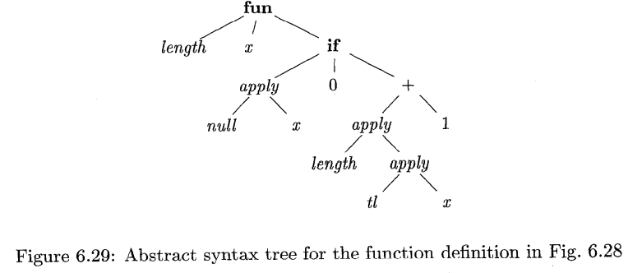

Q44. What is An Algorithm for Unification?
Unification is the process of determining whether two expressions, typically containing variables, can be made identical by applying substitutions. The goal is to find a substitution that makes the two expressions equal. It is commonly used in various fields like logic programming, type theory, and automated reasoning.

Unification Algorithm:
Unification involves transforming two type expressions or structures so that they become identical. Here's a high-level overview of the unification process, especially when extended to graphs with cycles (such as types with recursive structures):
- Type Expressions as Graphs: In the context of type theory, types are often represented as graphs. Type variables are represented by leaf nodes, and type constructors (like int, float, arrays, lists, etc.) are represented by interior nodes. The goal of unification is to check if two type graphs can be unified by finding a common structure that can substitute for the variables.
- Equivalence Classes: The nodes in the graph are grouped into equivalence classes. If two nodes belong to the same equivalence class, they are considered equivalent, meaning that they must represent the same type. During unification, the algorithm tries to ensure that corresponding nodes in different expressions belong to the same equivalence class.
- Unification Process: The unification process proceeds by comparing two expressions or type graphs. If the expressions contain variables, the algorithm attempts to substitute terms for those variables in such a way that the two expressions become identical.
- Substitution: A substitution is a mapping that associates a variable with an expression (or term). In the context of unification, a substitution S is the most general unifier (MGU) if it is the simplest (most general) way to make the two expressions identical.
- Example of Unification with Equivalence Classes: Let's say we have two type expressions, s and t. These expressions may involve type variables, and we want to determine if we can find a substitution that makes them identical.
  - The two type expressions are represented as graphs with nodes labeled according to their equivalence class.
  - After applying unification, the equivalence classes of the nodes will be merged where necessary.
  - If after unification the two graphs are identical (i.e., they have the same structure and values), we can say that the two expressions unify under a certain substitution.
- Handling Cycles: A more advanced unification algorithm can handle cyclic structures in types (e.g., recursive types like linked lists or trees). This is particularly useful in languages with recursive data types.

Example:
Consider two type expressions s and t, represented as type graphs. We apply unification by attempting to match nodes in the two graphs. If one graph has a node that is a type variable, and the other graph has a node that represents a type constructor, we attempt to substitute the variable with the constructor type. If we continue this process for all nodes and their corresponding children, we can find the most general unifier (MGU) that makes the two graphs identical.

Conclusion:
Unification is the process of determining whether two expressions can be made identical by substituting expressions for the variables in them. The unification algorithm can be extended to handle graphs, including cyclic graphs, which are useful for handling recursive data types. The key steps in unification are:
- Representing expressions as graphs.
- Grouping nodes into equivalence classes.
- Applying substitutions to match the nodes in the graphs.
- Finding the most general unifier (MGU) for the expressions.

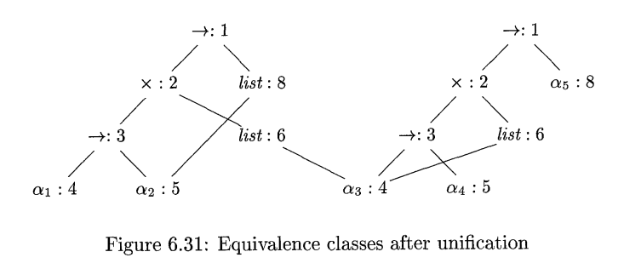
Q45. Define the following a) Topological Sort b) Dependency Graph c) Attribute d) Circular SDT

a) Topological sorting
for Directed Acyclic Graph (DAG) is a linear ordering of vertices such that for every directed edge u-v, vertex u comes before v in the ordering.
Note: Topological Sorting for a graph is not possible if the graph is not a DAG.
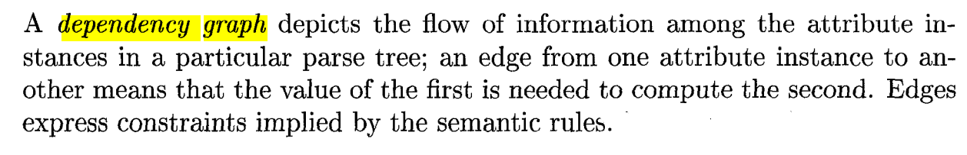
b)

c) Attribute Grammar
Attribute grammar is a special form of context-free grammar where some additional information (attributes) are appended to one or more of its non-terminals in order to provide context-sensitive information. Each attribute has well-defined domain of values, such as integer, float, character, string, and expressions.
Attribute grammar is a medium to provide semantics to the context-free grammar and it can help specify the syntax and semantics of a programming language. Attribute grammar (when viewed as a parse-tree) can pass values or information among the nodes of a tree

d) In a syntax-directed translation (SDT) scheme, circular SDT occurs when there’s a cycle in the dependency graph of attributes in a syntax tree, creating a circular dependency. This is problematic because it makes the attribute evaluation non-deterministic or impossible since each attribute relies on another in a cycle, preventing a clear order of evaluation.

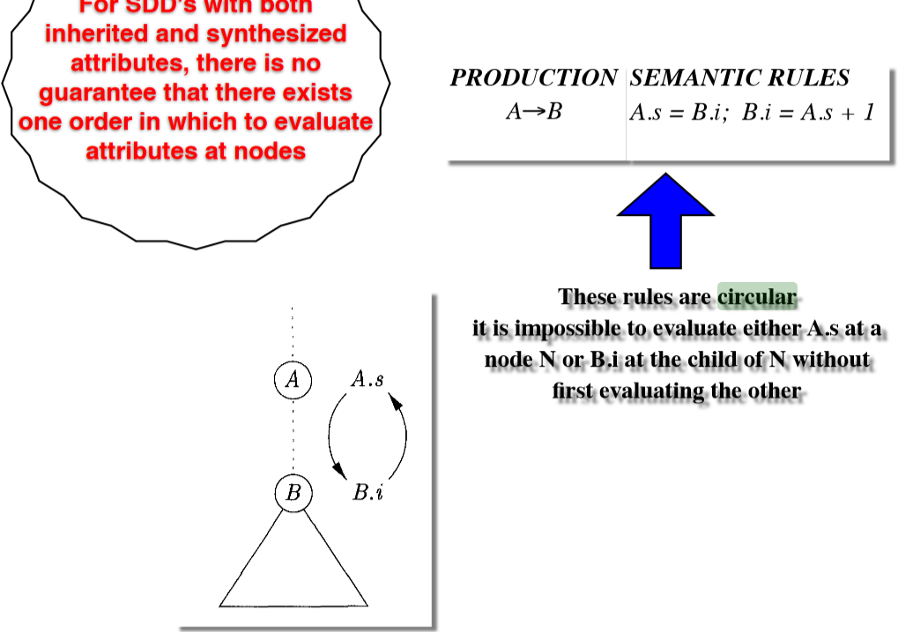
Q46. State and explain the syntax directed translation scheme for the desk calculator and give the parse tree and translation string.
W = 20 * 7+ 3
In a syntax-directed translation scheme (SDTS), translation is carried out based on the syntax of the language. Each production in the grammar is associated with semantic rules that define how to generate the translation.
For a simple desk calculator that evaluates arithmetic expressions, the language consists of numbers and the operators +, -, *, and /. The translation is done using arithmetic operations.

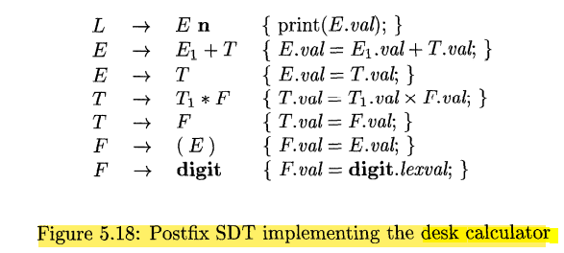

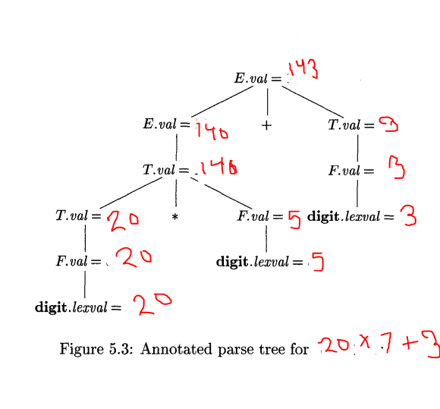

Q47. What is intermediate code representation? Explain various intermediate code representation schemes with the help of an example.
Intermediate Code Representation (ICR) is an intermediate form of the source program used by a compiler during the translation process. It serves as an abstraction between the high-level language and the machine code. The intermediate code is independent of both the source language and the target architecture, allowing the compiler to be more portable across different platforms. It simplifies optimization and facilitates the code generation phase of the compiler.
Here's an explanation of various Intermediate Code Representations (ICR) and how they are used in compilers:

1. Three-Address Code (TAC):
Three-Address Code is a representation where each instruction has at most three operands. It generally consists of an operator, two source operands, and a destination operand. The result of the operation is stored in a temporary variable or a target variable.
Example: For the expression a = b + c * d:
t1 = c * d
a = b + t1
Advantages:
- Simple and flexible.
- Easy to apply optimizations like common subexpression elimination and constant folding.

2. Quadruples:
Quadruples are a variant of Three-Address Code, consisting of four fields: the operator, two operands, and the result.
Example: For the expression a = b + c * d:
( *, c, d, t1) // t1 = c * d
( +, b, t1, a) // a = b + t1
Advantages:
- Simple structure.
- Supports easy translation to machine code.
- More detailed than TAC because it separates operator and operands clearly.

3. Triples:
Triples are similar to quadruples, but they only have three components: the operator and two operands. The result is represented by its position in the list of triples rather than a separate result field.
Example: For the expression a = b + c * d:
( *, c, d)
( +, b, 1) // 1 refers to the result of the first operation
( =, 2, a) // 2 refers to the result of the second operation
Advantages:
- More compact than quadruples.
- Useful for optimizing memory usage in intermediate code.

4. Indirect Triples:
Indirect triples are an extension of triples where each triple refers to an entry in an address table (like a pointer), which helps with more complex code generation and optimizations.
Example: Instead of directly storing ( *, c, d), we store the address of the operation in the table.
Advantages:
- Provides more flexibility for optimizations and changes in code generation.
- More efficient memory management than regular triples.

5. Static Single Assignment (SSA):
SSA is a form of Three-Address Code where each variable is assigned exactly once. It simplifies data flow analysis and enables many optimizations like constant folding and dead code elimination.
Example: For the expression a = b + c * d in SSA form:
t1 = c * d
t2 = b + t1
a = t2
Advantages:
- Simplifies optimizations such as constant propagation and redundancy elimination.
- Easier to perform alias analysis.
- Provides clear and unambiguous definition of variables.

6. Syntax Tree (Abstract Syntax Tree - AST):
An Abstract Syntax Tree (AST) represents the hierarchical syntactic structure of the source code. Each node in the tree represents a construct from the source code (such as an expression or operator). The tree doesn't represent the exact syntax but focuses on the logical structure.
Example: For the expression a = b + c * d, the AST would look like this:
=
/ \
a +
/ \
b *
/ \
c d
Advantages:
- Clear representation of the syntactic structure.
- Easy to apply syntax-driven transformations.
- Useful for higher-level optimizations like loop transformations and expression simplifications.

7. Directed Acyclic Graph (DAG):
A Directed Acyclic Graph is a graph where nodes represent computations or operations, and directed edges represent dependencies. There are no cycles in a DAG, making it suitable for optimizations like common subexpression elimination.
Example: For the expression a = b + c * d:
+
/ \
b *
/ \
c d
In this DAG, the multiplication c * d can be reused if the result is used multiple times in further expressions.
Advantages:
- Eliminates redundant computations (common subexpressions).
- Efficient representation for expression evaluation and optimization.
- Helps in simplifying and optimizing control flow, especially in compilers.
Q48. What do you mean by three address code? Convert the following statements into the Quadruple, Triple and Indirect triple representation: (A+B)*(C-D*E)
Three-Address Code (TAC) is an intermediate representation used in compilers where each instruction has at most three operands. Typically, it involves an operator, two operands, and a destination to store the result. TAC provides a simple way to express complex expressions and is used for optimization and translation to machine code.
To convert the expression (A + B) * (C - D * E) into different intermediate code representations (Quadruples, Triples, and Indirect Triples), we'll follow the standard process for these representations.

Expression:
(A + B) * (C - D * E)

Step-by-Step Conversion:
- First, break down the expression into subexpressions:
  - D * E
  - C - (D * E)
  - A + B
  - (A + B) * (C - (D * E))

1. Quadruple Representation:
In a quadruple, each instruction consists of four fields: operator, first operand, second operand, and result.
Quadruples:
( *, D, E, t1 ) // t1 = D * E
( -, C, t1, t2 ) // t2 = C - t1
( +, A, B, t3 ) // t3 = A + B
( *, t3, t2, t4 ) // t4 = t3 * t2
- t1 holds the result of D * E.
- t2 holds the result of C - t1.
- t3 holds the result of A + B.
- t4 holds the final result of (A + B) * (C - D * E).

2. Triple Representation:
In a triple, each instruction consists of three fields: operator, first operand, second operand, but the result is indicated by its position (index) in the list of triples rather than a separate variable name.
Triples:
( *, D, E ) // t1 = D * E
( -, C, 1 ) // t2 = C - t1 (where 1 refers to the result of the previous operation)
( +, A, B ) // t3 = A + B
( *, 2, 3 ) // t4 = t3 * t2 (where 2 and 3 refer to the results of the previous operations)
- t1, t2, t3, and t4 are implicit references to the results from the previous instructions.

3. Indirect Triple Representation:
In an indirect triple, each operation in the triple representation is referenced through an address table. Instead of directly referring to an operand or result, it points to an address where the result is stored.
Indirect Triples:
- First, create an address table for operations:
Address | Operation
1 | ( *, D, E )
2 | ( -, C, 1 )
3 | ( +, A, B )
4 | ( *, 2, 3 )
- Indirect triples will store the address of each operation instead of the result directly:
( *, D, E ) // Address 1
( -, C, 1 ) // Address 2
( +, A, B ) // Address 3
( *, 2, 3 ) // Address 4
Here, each operation is referenced indirectly by its address, making it possible to reorganize or optimize the code by simply adjusting the table.
Q49. What is type checking? Explain rules of type checking in context of semantic analysis.
Q50. Difference between Synthesized and Inherited Attribute.
S.NO | Synthesized Attributes | Inherited Attributes
1. | An attribute is said to be Synthesized attribute if its parse tree node value is determined by the attribute value at child nodes. | An attribute is said to be Inherited attribute if its parse tree node value is determined by the attribute value at parent and/or siblings node.
2. | The production must have non-terminal as its head. | The production must have non-terminal as a symbol in its body.
3. | A synthesized attribute at node n is defined only in terms of attribute values at the children of n itself. | An Inherited attribute at node n is defined only in terms of attribute values of n’s parent, n itself, and n’s siblings.
4. | It can be evaluated during a single bottom-up traversal of parse tree. | It can be evaluated during a single top-down and sideways traversal of parse tree.
5. | Synthesized attributes can be contained by both the terminals or non-terminals. | Inherited attributes can’t be contained by both, It is only contained by non-terminals.
6. | Synthesized attribute is used by both S-attributed SDT and L-attributed SDT. | Inherited attribute is used by only L-attributed SDT.
7. | 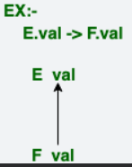 | 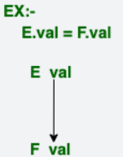

Q51. What is DAG? What are the advantages of DAG?

A DAG (Directed Acyclic Graph) is a graph that consists of nodes connected by directed edges, where the edges have a direction (from one node to another), and there are no cycles (i.e., there is no way to start at one node and follow the edges back to the same node). In a DAG, each node represents a computation or operation, and the edges represent dependencies between these operations.

Advantages of DAG:
- Eliminates Redundancy: In computational contexts like optimizing expressions or scheduling tasks, a DAG helps to eliminate redundant computations by ensuring that each computation is performed only once. If a computation or sub-expression is repeated, it is stored in a node, and subsequent uses of the same result can refer to the same node rather than recomputing it.
- Efficient Task Scheduling: In scheduling, a DAG is used to model task dependencies. This helps in ensuring that tasks are executed in the correct order (with respect to dependencies) and can be processed in parallel where possible. The absence of cycles guarantees that the tasks do not have circular dependencies, making scheduling feasible.
- Optimized Expression Evaluation: DAGs are used in compiler optimization to represent expressions. By breaking down an expression into sub-expressions (nodes) and representing dependencies between them as edges, the compiler can simplify and optimize the code by reusing common sub-expressions, reducing the total number of operations.
- Simplifies Data Flow: In data processing, DAGs are widely used to model data flow between operations. Since there are no cycles, the flow of data through operations is unidirectional, making it easier to track the processing of data from start to finish.
- Topological Sorting: A DAG allows for topological sorting, where nodes are arranged in such a way that for every directed edge from node u to node v, u comes before v in the ordering. This is useful in scheduling tasks, evaluating expressions, and other applications where dependencies must be respected.

Q52. What is translation string?

A translation string is the output generated by a syntax-directed translation scheme (SDTS) during the process of translating a program or expression from its source language into its target representation (such as machine code or an intermediate code).
In the context of a compiler or interpreter, a translation string represents the sequence of semantic actions or the evaluated result based on the syntactic structure of the source code. The translation string is generated as a result of applying the semantic rules defined in the SDTS to the parse tree of the program or expression.
For example, in arithmetic expressions:
- Given the expression 20 * 7 + 3, the translation string would represent the evaluated result of that expression, which is 143.
- If the translation scheme involves generating intermediate code or machine code, the translation string could be that code.

COMPILER DESIGN UNIT – 4 QUESTIONS

Q1. What is Symbol Table? What are its use? What are some symbol table implementations?
A compiler uses a symbol table to keep track of scope and binding information about names. The symbol table is searched every time a name is encountered in the source text. Changes to the table occur if a new name or new information about an existing name is discovered.
A symbol-table mechanism must allow us to add new entries and find existing entries efficiently. The two symbol-table mechanisms presented in this section are linear lists and hash tables. We evaluate each scheme on the basis of the time required to add n entries and make e inquiries. A linear list is the simplest to implement, but its performance is poor when e and n get large. Hashing schemes provide better performance for somewhat greater programming effort and space overhead. Both mechanisms can be adapted readily to handle the most closely nested scope rule.
It is useful for a compiler to be able to grow the symbol table dynamically, if necessary, at compile time. If the size of the symbol table is fixed when the compiler is written, then the size must be chosen large enough to handle any source program that might be presented. Such a fixed size is likely to be too large for most, and inadequate for some, programs.
Q2. How entries in a Symbol Table Takes Place?
Each entry in the symbol table corresponds to the declaration of a name. The format of entries does not need to be uniform because the information saved about a name depends on how the name is used. Each entry can be implemented as a record consisting of a sequence of consecutive words in memory. To keep symbol-table records uniform, it may be convenient for some information about a name to be stored outside the table entry, with only a pointer to this information kept in the record.
Information is entered into the symbol table at various times. Keywords are entered into the table initially, if at all. The lexical analyzer (discussed in Section 3.4) looks up sequences of letters and digits in the symbol table to determine if a reserved keyword or a name has been collected. With this approach, keywords must be in the symbol table before lexical analysis begins. Alternatively, if the lexical analyzer intercepts reserved keywords, they do not need to appear in the symbol table. If the language does not reserve keywords, it is essential to enter keywords into the symbol table with a warning of their possible use as keywords.
The symbol-table entry itself can be created when the role of a name becomes clear, with attribute values being filled in as the information becomes available. In some cases, the entry can be initiated by the lexical analyzer as soon as a name is encountered in the input. However, one name may denote several different objects, even within the same block or procedure. For example, the
int x;
struct x { float y, z; };
use x both as an integer and as the tag of a structure with two fields. In such cases, the lexical analyzer can only return the name itself (or a pointer to the lexeme forming that name) to the parser, rather than a pointer to the symbol-table entry. The record in the symbol table is created when the syntactic role of the name is discovered. For the declarations above, two symbol-table entries for x would be created: one as an integer and the other as a structure.
Attributes of a name are entered in response to declarations, which may be implicit. Labels are often identifiers followed by a colon, so recognizing such an identifier may involve entering this fact into the symbol table. Similarly, the syntax of procedure declarations specifies that certain identifiers are formal parameters.
Q3. How character in a name Stored in Symbol Table?
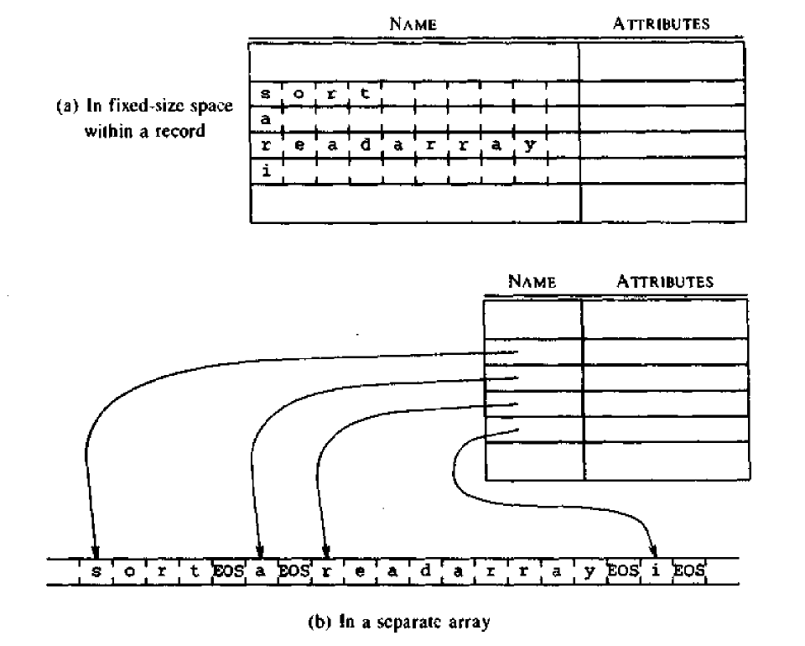
Q4. How Storage Allocation is done in symbol table?
Information about the storage locations bound to names at runtime is stored in the symbol table. First, consider names with static storage. If the target code is in assembly language, the assembler can manage the storage locations for various names. The compiler only needs to scan the symbol table after generating assembly code for the program and append assembly language data definitions for each name to the assembly language program.
If the compiler generates machine code, the position of each data object relative to a fixed origin, such as the beginning of an activation record, must be determined. The same applies to a block of data loaded separately from the program. For example, COMMON blocks in Fortran are loaded separately, and the positions of names relative to the beginning of the COMMON block in which they reside must be calculated. For reasons discussed in Section 7.9, the approach in Section 7.3 must be modified for Fortran, as offsets for names need to be assigned after all declarations for a procedure are processed and EQUIVALENCE statements have been handled.
For names whose storage is allocated on a stack or heap, the compiler does not allocate storage directly. Instead, it plans the activation record for each procedure, as described in Section 7.3.
Q5. Explain List Data structure for symbol-table.
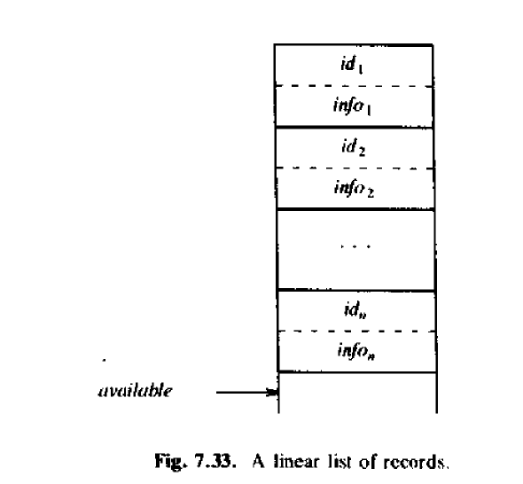

The simplest and easiest data structure to implement for a symbol table is a linear list of records, as shown in Fig. 7.33. A single array, or several equivalent arrays, is used to store names and their associated information. New names are added to the list in the order they are encountered. The position of the end of the array is marked by the pointer available, which points to where the next symbol-table entry will be added.
The search for a name proceeds backward from the end of the array to the beginning. When the name is located, the associated information can be found in the words that follow it. If the search reaches the beginning of the array without finding the name, a fault occurs, indicating that the expected name is not in the table.
Note that making and looking for entries in the symbol table follows this process.
Q6. How Hash Table are used in Symbol Table?
A hash table is a data structure that stores data in an associative manner. It allows for fast access to data through a process known as hashing, where a hash function is used to convert a key into an index in an array or a list. Here's a basic explanation:
The core idea behind a hash table is to use a hash function to map keys to indices in an array. A good hash function distributes keys uniformly across the table to minimize collisions (when two keys map to the same index).
The basic hashing scheme is illustrated in Fig. 7.34. The data structure consists of two parts:
- Hash Table: A fixed array of m pointers to table entries.
- Table Entries: Organized into m separate linked lists, called buckets. Each record in the symbol table is stored in exactly one of these lists. Some buckets may be empty.
The storage for the records can be drawn from an array of records, as discussed in the next section. Alternatively, the dynamic storage allocation facilities of the implementation language can be used to obtain space for the records, although this approach may result in some loss of efficiency.
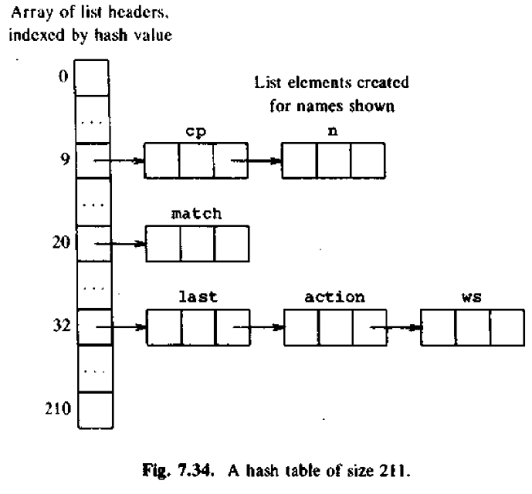

Q7. How scope information is represented in Symbol-table?
The entries in the symbol table correspond to declarations of names. When a name appears in the source text, the appropriate declaration entry for that name must be retrieved from the symbol table. The scope rules of the source language determine which declaration is relevant.
A simple approach is to maintain a separate symbol table for each scope. Essentially, the symbol table for a procedure or scope serves as the compile-time equivalent of an activation record. Information for non-local variables of a procedure is found by scanning the symbol tables of the enclosing procedures, following the scope rules of the language.
Alternatively, information about the local variables of a procedure can be attached to the node for that procedure in the syntax tree of the program. With this approach, the symbol table is integrated into the intermediate representation of the input.
Q8. Explain how data structured of Linked List is used in symbol table with example.
A Linked List can be used as a data structure for a symbol table to store and manage entries efficiently. Each entry in the symbol table typically represents a declaration of a name (such as a variable or function). A linked list allows for dynamic memory allocation, making it useful when the size of the symbol table may change as the program is parsed. The linked list can be particularly helpful when handling collisions in hash tables, or when maintaining separate lists for different scopes in a compiler.

Structure of the Linked List in Symbol Tables
- Nodes: Each node in the linked list represents an entry in the symbol table. Each node contains:
  - Name: The identifier (e.g., variable or function name).
  - Type: The data type or the kind of symbol (e.g., integer, function).
  - Scope: Information about the scope in which the symbol is valid (e.g., global, local).
  - Pointer to Next Node: A pointer that links to the next node in the list.

Example: Symbol Table Using Linked List
Let’s consider a simple scenario where we maintain a symbol table for variables in a program. We will use a linked list to store each variable's information.
In this example:
- var1 is a global integer variable.
- var2 is a local float variable.
- var3 is a global string variable.
Each entry is represented by a node in the linked list, and each node contains:
- The Name of the variable (var1, var2, var3).
- The Type of the variable (int, float, string).
- The Scope where the variable is valid (global, local).
- A pointer to the next node to link to the next symbol in the list.

How Linked List Works in Symbol Tables
- Insertion: When a new symbol is declared (e.g., a new variable or function), a new node is created and inserted into the linked list. If it's for a new scope, it may go into a different list (separate linked lists for different scopes).
- Search: When a name is encountered in the source code, the compiler will search through the linked list(s) to find the matching entry by traversing the nodes one by one.

Advantages of Using Linked List in Symbol Tables
- Dynamic Memory Allocation: Linked lists use memory dynamically, so the size of the symbol table can grow or shrink as needed during program parsing.
- Efficient Insertions: Insertions are relatively simple and quick, as we just need to create a new node and point it to the next one.
- Collisions Handling: In case of hash collisions, linked lists are a simple way to handle multiple entries that hash to the same index.

Disadvantages
- Search Time: Searching for an entry takes O(n)O(n)O(n) time in the worst case (where nnn is the number of entries in the list). This is slower compared to other structures like hash tables that can offer O(1)O(1)O(1) search time.
- Extra Memory: Each node in a linked list requires extra memory for the pointer to the next node.
Q9. Explain how data structured of tree is used in symbol table with example.
In a symbol table, a tree structure is used to efficiently store and manage symbols (such as variables, functions, or classes) in programming languages, particularly when dealing with hierarchical data. A tree allows quick lookups, insertions, and deletions of symbol entries, while also supporting scope and namespace management, which is useful in compilers and interpreters.

Tree Structure in Symbol Tables
A tree-based structure in a symbol table can be used to maintain symbols in a hierarchical way, where each node represents a symbol, and the tree structure allows efficient searching, insertion, and deletion operations.
- Root Node: The root represents the global scope or the main entry point.
- Child Nodes: These represent local scopes, such as functions or blocks, which may contain variables, classes, etc.
- Leaf Nodes: These represent the actual symbols (e.g., variable names, function names).

Types of Trees Used
- Binary Search Tree (BST): A common choice where each node follows the binary tree properties. The left child has a smaller value than the parent, and the right child has a larger value.
- AVL Tree/Red-Black Tree: These are self-balancing binary search trees used to maintain balanced height, ensuring O(log⁡n)O(\log n)O(logn) lookup, insert, and delete operations.
- Trie: A specialized tree structure used for efficient string matching, commonly used in symbol tables when dealing with string-based identifiers.
Example of a Tree-Based Symbol Table
int x;
float y;
int z;
x (int)
/ \
z (int) y (float)

Advantages of Using Trees in Symbol Tables
- Efficient Search: Tree structures, particularly balanced ones like AVL or Red-Black Trees, offer efficient search operations with a time complexity of O(log⁡n)O(\log n)O(logn), making lookups faster than linear search in lists.
- Hierarchical Structure: Trees naturally handle hierarchical relationships (e.g., scopes or namespaces), making them ideal for managing nested scopes or blocks.
- Balanced Trees: Self-balancing trees ensure that the symbol table remains balanced and maintains efficient time complexity for search, insertion, and deletion.

Disadvantages
- Complexity: Implementing and maintaining a balanced tree (e.g., AVL or Red-Black tree) is more complex than using simpler data structures like arrays or linked lists.
- Memory Overhead: Trees require extra memory for pointers (left and right child pointers), which can lead to additional space overhead compared to other data structures.
Q10. What are Lexical Errors and error-recovery actions?
In lexical analysis, errors at the lexical level are typically difficult to identify with the lexical analyzer alone, as its primary job is to break down the input string into valid tokens without understanding the broader context. Lexical analyzers use regular expressions or other pattern matching techniques to identify the basic components of a program (keywords, operators, identifiers, etc.). However, in some cases, it may encounter situations where it cannot immediately determine whether an identifier is a misspelling of a keyword or an undeclared function. This ambiguity is an example of a lexical error.
When such errors occur, it's often left to later phases of the compiler (like syntax analysis or semantic analysis) to provide more context and give a better understanding of the error. However, when the lexical analyzer encounters a situation where no valid token can be recognized from the remaining input, recovery strategies are needed to allow the compiler to continue processing the rest of the input.

Panic Mode Recovery:
One of the simplest recovery strategies is panic mode recovery. In this approach, when the lexical analyzer encounters an error (i.e., when no valid token can be matched), it discards successive characters from the remaining input until it finds a valid token. This is an efficient but potentially imprecise method, as it allows the analyzer to skip over part of the input but may not handle the specific error well. It can confuse the parser or cause unintended skips in the program but is useful in an interactive environment where quick feedback is needed.

Other Error Recovery Actions:
Beyond panic mode recovery, there are other recovery actions that can be applied in different situations to fix or handle lexical errors. These actions include:
- Deleting an extraneous character: If the analyzer encounters an unexpected or extra character that doesn’t fit into any valid token, it can remove it from the input to continue processing.
- Inserting a missing character: If a token is expected but a character is missing, the analyzer can insert a character to make the input syntactically valid.
- Replacing an incorrect character by a correct one: If a character in a token is incorrect (such as a typo), the analyzer may correct it by replacing the incorrect character with the right one.
- Transposing two adjacent characters: In cases where two characters are swapped, this recovery technique involves switching them to form the correct token.
Error recovery in lexical analysis is crucial to ensure that the compiler can continue processing the input even in the presence of lexical errors. The panic mode recovery approach is simple and fast, but other techniques like deleting, inserting, replacing, or transposing characters can provide more precise error recovery, depending on the specific scenario. These strategies help maintain the flow of the compilation process and prevent the compiler from failing completely due to minor lexical issues.
Q11. What are Syntactic Error and errors seen in other phases? State all general error-recovery Strategies?
Syntactic errors are violations of the grammatical rules of a programming language. In this section, we will explore the nature of syntactic errors and general strategies for error recovery. Specifically, we will discuss two error recovery methods—panic-mode recovery and phrase-level recovery—and explain how they are implemented in conjunction with individual parsing methods. The implementation of each strategy requires the compiler writer’s judgment, but we will provide guidance on how to approach these challenges.
If a compiler were only tasked with processing correct programs, its design and implementation would be much simpler. However, since programmers often write incorrect programs, a good compiler should assist in identifying and locating errors. It's noteworthy that, although errors are common, few programming languages are designed with error handling in mind. In fact, if spoken languages required the same syntactic accuracy as programming languages, our civilization would be radically different. Most programming language specifications do not explicitly state how a compiler should respond to errors; this responsibility is left to the compiler designer. Planning error handling from the beginning can simplify the structure of the compiler and improve its ability to respond to errors.
Programs can contain errors at many different levels, including:
- Lexical errors, such as misspelling an identifier, keyword, or operator.
- Syntactic errors, such as an arithmetic expression with unbalanced parentheses.
- Semantic errors, such as applying an operator to an incompatible operand.
- Logical errors, such as an infinitely recursive call.
Much of the error detection and recovery in a compiler occurs during the syntax analysis phase. This is because many errors are syntactic in nature, or they are exposed when the tokens from the lexical analyzer do not conform to the grammar of the language. Modern parsing methods can efficiently detect syntactic errors, while detecting semantic and logical errors at compile time is much more difficult. In this section, we will introduce basic techniques for recovering from syntax errors and discuss how these techniques are implemented in different parsing methods.
The error handler in a parser aims to meet three main goals:
- It should report errors clearly and accurately.
- It should recover from each error quickly enough to continue detecting subsequent errors.
- It should not significantly slow down the processing of correct programs.
Achieving these goals can be challenging. Fortunately, many common errors are simple, and a relatively straightforward error-handling mechanism is often sufficient. However, in some cases, an error may have occurred long before it is detected, and pinpointing the exact nature of the error can be difficult. In such cases, the error handler may have to make educated guesses about what the programmer intended.
Several parsing methods, such as LL and LR parsers, are designed to detect errors as soon as possible. These parsers have the viable-prefix property, meaning they can detect an error as soon as they encounter a prefix of the input that cannot be a valid prefix of any string in the language.
Error-Recovery Strategies
Parsers can employ various strategies to recover from syntactic errors. Although no single strategy is universally ideal, some methods have broad applicability. The main strategies include:
- Panic Mode
- Phrase-Level Recovery
- Error Productions
- Global Correction
Panic Mode Recovery:
Panic mode is the simplest error recovery method and can be used by most parsing techniques. When an error is detected, the parser discards input symbols one at a time until it encounters a synchronizing token, which is a predefined delimiter (like a semicolon or end-of-line marker) that clearly signifies the end of a statement or block. The synchronizing tokens are chosen based on the language's syntax, and while panic mode often skips over parts of the input, it has the advantage of simplicity and ensures that the parser will not enter an infinite loop. This method works well in scenarios where errors within a single statement are uncommon.
Phrase-Level Recovery:
In phrase-level recovery, the parser performs a local correction on the input when it encounters an error. It might replace a prefix of the remaining input with a string that allows parsing to continue. For example, it might change a comma to a semicolon, remove an extra semicolon, or insert a missing one. The specific correction is determined by the compiler designer. However, care must be taken to avoid infinite loops, such as by inserting something in front of the current input symbol, which could disrupt the flow of the program.
Error Productions:
If we anticipate specific errors, we can augment the grammar with error productions that define the erroneous constructs. These error productions are incorporated into the parser, so when an error production is used, the parser can generate a diagnostic indicating the error in the input. This method requires prior knowledge of common mistakes in the source language and can provide detailed error messages for the programmer.
Global Correction:
The goal of global correction is to minimize the changes needed to process an incorrect input string. Some algorithms can identify the minimal sequence of changes (insertions, deletions, and substitutions) required to transform the incorrect input into a syntactically valid string. However, these methods tend to be computationally expensive in terms of time and memory usage, making them impractical for most real-world compilers. As a result, they remain primarily of theoretical interest.

Q12. Explain errors and error-recovery in rest of the phases?

Errors in Intermediate Code Generation and Recovery
Errors:
- Invalid Intermediate Representation:
The intermediate code does not correctly represent the semantics of the source program, e.g., missing assignments or incorrectly ordered operations.
- Type Mismatch:
Incorrect type casting or operations between incompatible data types.
- Uninitialized Variables:
Generating intermediate code that references variables without initialization.
- Infinite Loops or Dead Code:
Loops with no exit condition or unreachable code segments in the intermediate representation.
Recovery Strategies:
- Type Checking and Conversion:
Ensure type compatibility by inserting explicit type conversions during intermediate code generation.
- Variable Initialization Checks:
Add default initialization for variables to prevent runtime errors.
- Static Analysis:
Use data flow analysis to detect unreachable code or infinite loops in the intermediate representation.
- Debugging Symbols:
Annotate intermediate code with debugging information to trace errors back to source code.

Errors in Code Optimization and Recovery
Errors:
- Incorrect Optimization:
Optimizations that alter the program's intended semantics, such as removing live code mistakenly identified as dead.
- Redundant Optimizations:
Applying the same optimization multiple times unnecessarily increases compilation time without benefits.
- Over-Aggressive Loop Transformations:
Loop unrolling or invariant code motion may disrupt program correctness if the conditions for their application are not met.
- Resource Constraints:
Excessive memory or register usage caused by poor optimization strategies.
Recovery Strategies:
- Validation of Optimizations:
Verify optimizations do not change program behavior using equivalence checks or test cases.
- Conservative Optimization:
Prioritize correctness over aggressive optimizations by applying safer and well-tested transformations.
- Fallback Mechanism:
If an optimization fails or introduces issues, revert to the original, unoptimized code.
- User Control:
Allow users to specify optimization levels or disable specific optimizations for critical sections.

Errors in Code Generation and Recovery
Errors:
- Incorrect Target Code:
Errors in translating intermediate code into machine instructions, such as using wrong addressing modes or operations.
- Register Allocation Failures:
Inadequate registers allocated, leading to excessive memory access or invalid register usage.
- Platform-Specific Errors:
Generated code does not conform to the target architecture’s constraints or calling conventions.
- Incorrect Resource Management:
Memory leaks or incorrect deallocation during code generation.
Recovery Strategies:
- Fallback to Simpler Instructions:
Use simpler, universal instructions if complex instructions fail to map correctly to the target platform.
- Register Spilling:
Store variables in memory when registers are insufficient and reload them as needed.
- Instruction Verification:
Check generated instructions for validity against the target architecture specification.
- Runtime Checks:
Insert runtime checks for critical resources like memory usage to detect potential issues early.
Q13. Explain Code Optimization.
To create an efficient target language program, a programmer must rely on more than just an optimizing compiler. Optimizing compilers aim to apply program transformations that provide the greatest benefit with the least effort. These transformations must adhere to several key properties to ensure program correctness and efficiency.
Firstly, transformations must preserve the meaning of the program. This means they cannot alter the program's output for any given input or introduce errors, such as division by zero, that were absent in the original program. It is critical to maintain program correctness at all times, even if it means missing certain optimization opportunities.
Secondly, transformations should, on average, result in a measurable performance improvement, typically by speeding up the program. While reducing the size of the compiled code may also be desirable, it is generally considered less critical than improving execution speed. Not all transformations will benefit every program, and occasionally, an optimization might marginally slow down a program. However, as long as the average outcome is positive across multiple programs, the transformation is deemed beneficial.
Third, a transformation must justify the effort it requires. It is inefficient for a compiler writer to invest significant intellectual and computational resources in implementing a code-improving transformation if the resulting improvements in target program performance do not outweigh these costs. Transformations that are simple, effective, and provide clear benefits, such as local or "peephole" optimizations, are generally worth including in any compiler. These types of transformations are straightforward to implement and deliver tangible improvements in execution efficiency.
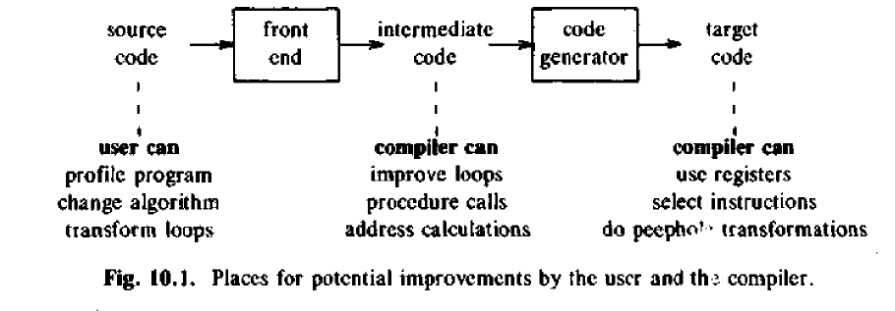
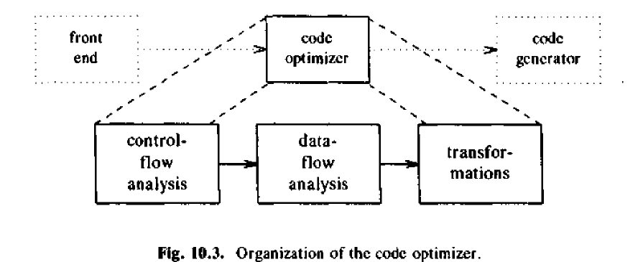

Q14. Name all the principal sources of optimization.
The principal sources of optimization in compiler design include the following:
- Common Subexpression Elimination
  - Eliminates redundant calculations of expressions already computed earlier in the code.
- Copy Propagation
  - Replaces a variable with its value if it simply duplicates another variable's value.
- Dead-Code Elimination
  - Removes code that computes results never used or is unreachable.
- Constant Folding
  - Computes constant expressions at compile time instead of runtime.
- Strength Reduction
  - Replaces expensive operations (e.g., multiplication) with cheaper ones (e.g., addition or shifts).
- Code Motion (Loop-Invariant Code Motion)
  - Moves calculations that produce the same result every loop iteration outside the loop.
- Induction Variable Optimization
  - Simplifies or replaces induction variables in loops to improve performance.
- Inline Expansion
  - Replaces function calls with the function’s body to avoid overhead associated with calls.
- Peephole Optimization
  - Examines a small set of instructions and replaces them with faster or shorter equivalents.
- Constant Propagation
  - Replaces variables that have constant values with the constants themselves.
- Loop Unrolling
  - Expands loop iterations to decrease overhead and increase parallelism.
- Branch Optimization
  - Simplifies or removes unnecessary conditional or unconditional branches.
- Register Allocation
  - Minimizes memory access by efficiently using CPU registers.
- Function-Preserving Transformations
  - Techniques like eliminating redundant computations while preserving the output.
- Inter-Procedural Optimization
  - Optimizations that analyze and improve across multiple functions or procedures.

- Instruction Scheduling
  - Reorders instructions to minimize delays due to dependencies or hardware limitations.
Q15. Explain Function-Preserving Transformations.
The compiler uses function-preserving transformations to improve a program's performance without altering its output or functionality. These transformations include:
- Common Subexpression Elimination
Identifies and eliminates redundant calculations of the same expression, saving computation time by reusing previously computed values.
- Copy Propagation
Replaces occurrences of variables with their assigned values, reducing unnecessary copies and improving clarity.
- Dead-Code Elimination
Removes code that computes values that are never used, eliminating wasteful operations and unnecessary instructions.
- Constant Folding
Evaluates constant expressions at compile time instead of runtime, reducing execution overhead.
These transformations can be applied locally within basic blocks using Directed Acyclic Graph (DAG) representations or globally across multiple basic blocks for more comprehensive optimization. Local transformations are generally applied first to simplify and streamline the code at a granular level, preparing it for global optimizations.
Q16. Write the different code-improving transformation.
Code-Improving Transformations are compiler optimizations aimed at enhancing the performance or efficiency of a program without altering its functionality. These transformations are categorized into function-preserving and performance-enhancing techniques.
Code-improving transformations can be classified based on their scope as local or global:
- Local Transformations
These are optimizations applied within a single basic block (a straight-line code sequence with no branches in except at the entry and no branches out except at the exit). Since they focus on a confined scope, they require analyzing only the statements in the block. Examples include:
  - Eliminating redundant calculations (common subexpressions).
  - Simplifying constant expressions.
  - Removing unused variables or instructions (dead-code elimination).
- Global Transformations
These optimizations span multiple basic blocks and require more comprehensive program analysis. They consider the flow of control across the entire program to optimize variables and expressions that influence other parts of the code. Examples include:
  - Moving loop-invariant computations outside loops.
  - Propagating values and expressions across blocks (global copy propagation).
  - Removing globally unused variables or functions.
eg:- Function-Preserving Transformations, Performance-Enhancing Transformations
Q17. Explain elimination of common sub expression.
The elimination of common subexpressions is a code optimization technique where redundant computations of the same expression are avoided. An expression E is identified as a common subexpression if it has been computed earlier in the program, and the values of the variables in E have not been altered since the last computation.

Steps for Elimination
- Identify duplicate computations of E within a basic block or across the program.
- Check if the variables involved in E remain unchanged between the computations.
- Replace subsequent occurrences of E with the previously computed value.
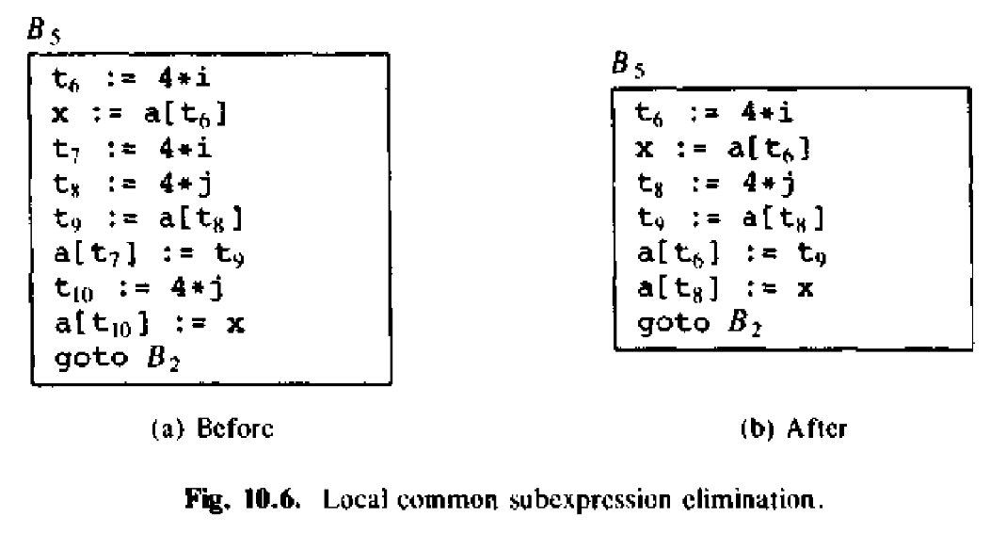

Q18. Explain Copy Propagation.
Copy propagation is a code optimization technique that eliminates unnecessary assignments of the form f := g (called copy statements). These statements can often be simplified by directly using the value of g wherever f is used in the program. The goal is to remove redundant assignments and propagate the value of g through the program.
For example, consider an assignment x := tj in a block of code. If tj is assigned to x and x is subsequently used in the program, we can propagate the value of tj directly instead of using x. This reduces the number of variables in the program and avoids unnecessary storage and retrieval operations.
Copy propagation works by replacing the occurrences of f with g wherever f is used after the copy statement. For instance, in the given example, the assignment x := tj can be replaced with the use of tj directly, simplifying the program and improving its efficiency.
Here’s how the transformation works step-by-step in the example:
- Before copy propagation:
  - x := tj
  - a[t2] := t5
  - Mt4] := t3
  - goto B2
- After copy propagation:
  - The assignment x := tj can be removed and tj can be used directly in place of x. This eliminates the redundant variable x, making the code more efficient.
By applying copy propagation, we optimize the program by removing unnecessary variables and assignments, making the code more concise and reducing execution time
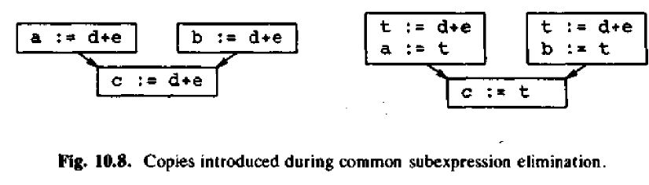
Q19. What is dead code elimination.
Dead code elimination is an optimization technique used by compilers to remove unnecessary code that does not affect the program's behavior. A variable is considered "live" if its value is used later in the program, and it is considered "dead" if its value is never used. Dead code refers to the statements that compute values which are never used in subsequent parts of the program.
For example, consider a situation where a variable debug is assigned a value of false, and later, an if statement checks the value of debug to conditionally execute a print statement. If the compiler can deduce through data-flow analysis that the value of debug is always false before the if statement, it can safely eliminate the if (debug) check and the print statement, because they will never execute.
Here’s how dead code elimination works:
- Identifying dead code: The compiler identifies variables whose values do not impact any future computations or outputs.
- Removing dead code: The compiler removes the code associated with these variables. For example, if a statement like debug := false is found and the program flow guarantees that this value is never used later (because of a subsequent check like if (debug)), both the assignment and the conditional check can be eliminated.
- Further optimization: Dead code elimination is often performed after other optimizations like copy propagation. For example, after copy propagation eliminates redundant assignments, dead code may emerge, which can then be removed.
By removing dead code, the program becomes smaller, faster, and more efficient because the compiler eliminates unnecessary operations that would never contribute to the final output.
Q20. What is Loop Optimization? What are the different techniques for it?
Loop optimization is crucial for improving the performance of a program, especially since inner loops often contribute significantly to the overall execution time. The main goal of loop optimization is to reduce the number of instructions executed in the loop, thereby improving the program's efficiency. While optimizations outside the loop can be beneficial, focusing on the inner loops, where most time is spent, is particularly effective.
Eg:- Code Motion, Induction Variables and Reduction in Strength.
Q21. Explain Code Motion in detail.
Code motion is a powerful optimization technique aimed at reducing the amount of redundant computation inside loops. The key idea is to identify expressions or computations that yield the same result each time the loop executes—referred to as loop-invariant computations—and move them outside the loop. This reduces the number of computations that need to be performed in each iteration of the loop, improving performance, especially for loops that iterate many times.
For example, consider the following while loop:
while (i < limit - 2) {
// Some statement that does not change 'limit'
}
In this loop, the expression limit - 2 is evaluated in every iteration, but its result is always the same. This is a loop-invariant computation because the value of limit - 2 does not depend on the loop's variables (like i), so it can be calculated once before the loop starts and reused during each iteration.
Applying code motion, we can rewrite the loop as:
t = limit - 2; // Compute the loop-invariant expression once
while (i < t) {
// Some statement that does not change 'limit' or 't'
}
By moving the computation of limit - 2 outside the loop, we reduce the number of times the expression is evaluated, making the program more efficient. This transformation can be applied to other expressions or computations that do not change within the loop, leading to further reductions in redundant code execution.

Q22. Explain Induction Variables and Reduction In Strength.
Induction Variables and Reduction in Strength
Induction variables are variables in a loop that change by a constant amount with each iteration. They are typically used to represent loop indices or counters. In a loop, induction variables often follow a predictable pattern, such as being incremented or decremented by a fixed value (e.g., i = i + 1 or j = j - 1).
When optimizing code, induction-variable elimination focuses on reducing the number of induction variables in a loop. If there are multiple induction variables that follow a consistent relationship, it's possible to eliminate some of them by expressing one in terms of the others or simplifying their usage. For example, if a variable t4 is assigned 4 * j in each iteration and its value is always updated by the same constant (4), then this relationship can be simplified or eliminated using induction-variable elimination.
Reduction in Strength is a technique used to replace expensive operations, such as multiplication or division, with cheaper operations, typically addition or subtraction. For example, in a loop where a variable t4 is calculated as t4 = 4 * j, this multiplication can be replaced with a repeated addition: t4 = t4 - 4, reducing the computational cost.
In the example provided, we have the relationship t4 = 4 * j, which holds throughout the loop. When j is decremented (i.e., j = j - 1), t4 also decreases by 4. The process of induction-variable elimination allows us to replace t4 = 4 * j with t4 = t4 - 4, maintaining the correct relationship but optimizing the loop by avoiding the multiplication.
After applying reduction in strength to the loop, the remaining induction variables are simplified, and the values of i and j can be expressed in terms of t2 and t4, which allows further optimizations. For instance, if t2 is related to i and t4 to j (e.g., t2 = 4 * i and t4 = 4 * j), we can replace the test t2 >= t4 with i >= j. This simplifies the logic and makes the variables i and j unnecessary in the loop, thus eliminating dead code (i.e., code that is no longer used) and further reducing the number of instructions executed.
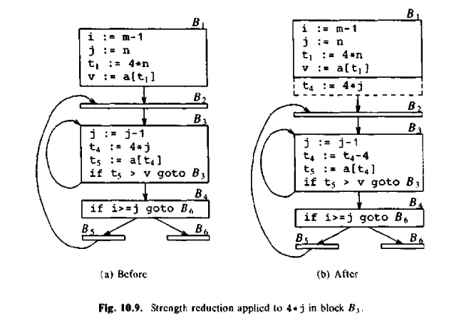
Through these transformations, the code becomes more efficient by reducing unnecessary operations and eliminating dead variables. The resulting code has fewer instructions and executes faster, particularly for nested loops where the optimizations have a significant impact on performance.
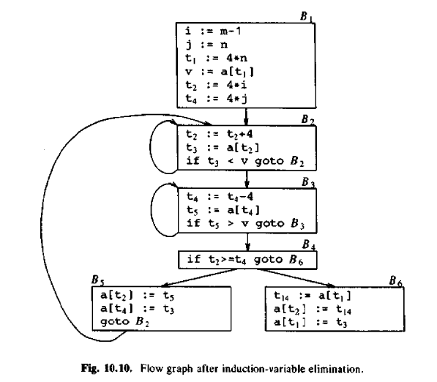
Q23. Explain Optimization of basic blocks using DAG.
Construction of Basic Blocks Using DAG
A Directed Acyclic Graph (DAG) is an effective structure for representing and optimizing basic blocks in a program. A basic block is a sequence of instructions with no branches except at the entry and exit points. By constructing a DAG for a basic block, we can perform several optimizations, such as common subexpression elimination, dead-code elimination, and algebraic transformations like reduction in strength.
In the DAG construction process, each node represents either an operand (a variable value) or an operation (a statement) in the basic block. Here’s how it works:
- Nodes for Variables: Each variable in the block is represented as a node.
- Nodes for Operations: For each operation (e.g., an assignment or computation), there is a node in the DAG. This node is labeled with the operator used in the statement (e.g., +, -).
- Children of Nodes: The children of an operation node correspond to the operands used in that operation. These operands could either be variables or the results of previous operations.
- Definition Tracking: For each statement, a node is associated with the last definition of the operands it uses. This ensures that we track the most recent value of variables and avoid using outdated ones.
- Output Nodes: If a variable is live on exit from the block, its corresponding node is marked as an output node.

Optimization Example Using DAG: Common Subexpression Elimination
Common subexpression elimination is a key optimization that reduces redundant calculations by identifying expressions that are computed more than once. The DAG can detect such expressions by looking for nodes that have the same operator and identical operands (i.e., the same children). When a new operation is about to be added to the DAG, if it matches an existing operation node, the previously computed result can be reused.

Example 10.5: Constructing a DAG for a Basic Block
Consider the following sequence of statements in a basic block:
a := b + c
b := a - d
c := b + c
d := a - d
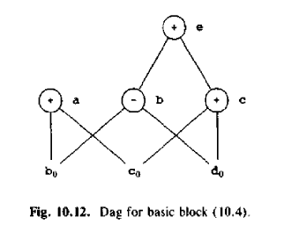
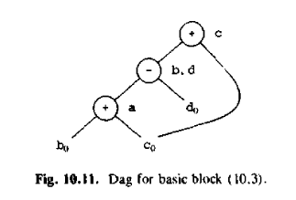

Q24. What is Code Generation?
Code generation is the final step in the compiler process, where an intermediate representation (IR) of the source program is translated into an equivalent target program. This phase involves generating machine code or assembly code that can be executed on a specific hardware platform.
Key aspects of the code generation phase include:
- Input and Output:
  - The code generator receives an intermediate representation (IR) of the program as input. This representation is usually a lower-level, more structured form of the original source code, making it easier for the code generator to process.
  - The output is typically assembly language or machine code that can be executed by a computer.
- Correctness:
  - The generated target code must perform the same operations as the original program. The compiler ensures that the correctness of the program is maintained throughout the transformation from IR to the final code.
- Efficiency:
  - The generated code should make optimal use of the resources available on the target machine, such as registers, memory, and the processor’s instruction set. The goal is to produce code that is efficient in terms of execution time and memory usage.
  - In addition, the code generation process itself must be efficient to handle large programs and reduce the compilation time.

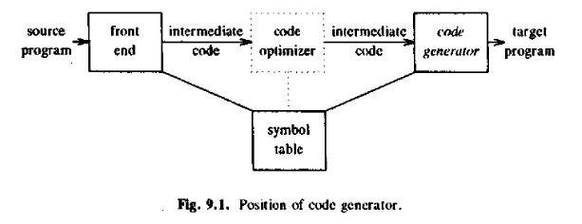
Q25. What are issues in the design of a code generator.
The design of a code generator involves addressing several fundamental issues that are common across most target languages and systems. These issues ensure that the generated machine code is both efficient and correct.
Q26. Explain “Input to the Code Generator” issue face by Code Generator.
The "Input to the Code Generator" problem refers to the challenge of processing the data given to the code generator in the compilation process. This input consists of two primary components:
- Intermediate Representation (IR) of the Source Program: The IR is the output of the front end of the compiler and serves as a bridge between the high-level source code and the target machine code. It can take various forms, including linear representations (e.g., postfix notation), three-address code (e.g., quadruples), virtual machine representations (e.g., stack machine code), or graphical representations (e.g., syntax trees and Directed Acyclic Graphs or DAGs). The choice of IR affects how the compiler performs optimizations and generates the final machine code.
- Symbol Table: This table contains information about variables, constants, and functions used in the source program. It includes details like data types, memory locations, and run-time addresses. The code generator uses the symbol table to determine the run-time addresses of the data objects referenced in the intermediate representation.
The challenge lies in efficiently interpreting and transforming these representations into executable machine code while managing data addresses and optimizing for performance. Despite different IRs, the core principles of code generation remain similar, focusing on the accurate mapping of operations and memory management.
Q27. Explain the issue of target program in code-generation.
Target program: The target program is the output of the code generator. The output may be absolute machine language, relocatable machine language, or assembly language.
- Absolute machine language as output has the advantages that it can be placed in a fixed memory location and can be immediately executed. For example, WATFIV is a compiler that produces the absolute machine code as output.
- Relocatable machine language as an output allows subprograms and subroutines to be compiled separately. Relocatable object modules can be linked together and loaded by a linking loader. But there is added expense of linking and loading.
- Assembly language as output makes the code generation easier. We can generate symbolic instructions and use the macro-facilities of assemblers in generating code. And we need an additional assembly step after code generation.
Q28. Explain memory management in code-generation.
Memory management in code generation involves mapping the names in the source program to actual memory addresses where the data objects will reside during runtime. This process is carried out collaboratively by the front-end and code generator.
- Symbol Table and Data Allocation: The symbol table holds information about variables and their attributes (e.g., type, size). Each declaration in the source code is examined to create entries in the symbol table, which include the necessary storage width for each variable based on its type. The code generator uses this information to determine relative addresses for variables in the procedure's data area, allocating memory accordingly.
- Static and Stack Allocation: When generating code, the compiler must decide how to allocate memory. Two common strategies are:
  - Static Allocation: Memory is allocated at compile-time for global variables and constants.
  - Stack Allocation: Memory is dynamically allocated at runtime for local variables and function calls, typically using a stack.
- Handling Addresses in Machine Code: When generating machine code from intermediate representations like three-address code, labels (used for control flow, such as "goto" statements) need to be converted into addresses. This process is similar to backpatching, where a label refers to a position in the code that hasn't yet been generated.
For example, in a sequence of quadruples, each label (representing a jump or branch) refers to an instruction that is not yet generated. The address of these instructions is determined by maintaining a count of how many machine instructions have been generated so far. If a label is forward-referenced (i.e., the target comes later), the address isn't known immediately. In such cases, the code generator stores the location of the target address in a list and then updates the address once the target instruction is generated.
This dynamic management of addresses ensures that the generated machine code correctly reflects the logical flow and memory usage of the program, even when dealing with forward and backward jumps or references.
Q29. What is Instruction Selection?
Instruction Selection is the process of determining how a high-level operation or intermediate code (such as three-address code) should be translated into the machine-specific instructions of the target architecture. The difficulty and effectiveness of this process depend on several factors:
- Instruction Set Characteristics: The nature of the target machine's instruction set (its uniformity, completeness, and how it handles various data types) greatly influences instruction selection. If the instruction set does not handle certain data types uniformly, special handling for those cases is required, which complicates the code generation process.
- Efficiency Concerns: Instruction selection can be straightforward if efficiency is not a concern. For each type of intermediate instruction (such as a three-address statement), a predefined code template (skeleton) can be applied. For example, an instruction like x := y + z might be translated to:
MOV y, R0 ; //load y into register R0
ADD z, R0 ; //add z to R0
MOV R0, x ; //store the result from R0 into x
However, this approach can lead to inefficiencies, especially in terms of redundant instructions.
- Code Redundancy: A simple statement-by-statement translation often produces suboptimal code. For example, if two consecutive statements involve redundant operations, such as storing a value into a register only to load it again, the result can be unnecessary computation and memory access. Consider the sequence:
MOV b, R0 ; load b into R0
ADD c, R0 ; add c to R0
MOV R0, a ; store the result in a
MOV a, R0 ; load a into R0
ADD e, R0 ; add e to R0
MOV R0, d ; store the result in d
Here, the MOV a, R0 and MOV R0, a operations are redundant. The code could be optimized to avoid these unnecessary steps, improving performance and reducing size.
- Target Machine Features: A target machine with a rich instruction set may provide multiple ways to implement certain operations. For instance, a machine might have specialized instructions for operations like addition or multiplication, allowing for more efficient code generation than if only generic instructions were available. The selection of instructions must account for both the machine's capabilities and the specific optimization goals (such as execution speed or code size).
Overall, instruction selection is a critical step in code generation that balances the need for correct translation with the goal of producing efficient and optimized machine code.
Q30. What is Register Allocation?
Register Allocation is the process of selecting a set of variables that will reside in the processor’s registers at various points in the program, ensuring efficient use of the limited number of registers available. Efficient register allocation is crucial because register operands are much faster to access than those stored in memory, and instruction execution involving registers is typically shorter and more efficient.
This process is divided into two main subproblems:
- Register Allocation: This phase determines which variables should be stored in the processor's registers at a given point in the program. This is a challenging task because registers are limited in number, and the program’s execution flow often requires moving variables in and out of registers.
- Register Assignment: Once the variables for register allocation are chosen, the next step is to assign specific registers to these variables. This phase is often influenced by the architecture of the target machine, which may have specific rules for how registers can be used.
Finding an optimal register allocation and assignment is an NP-complete problem, meaning that it is computationally expensive to guarantee the most efficient use of registers. The problem is further complicated by hardware and operating system constraints, which may require that certain register usage conventions be followed. For example, some machines may require pairs of registers to be used together for certain operations. The IBM System/370 is an example, where integer multiplication and division involve register pairs. In this case, the 64-bit dividend is stored in an even-odd register pair, with the remainder in the even register and the quotient in the odd one after division.
The process of register allocation becomes even more complex when considering machine-specific requirements, such as register-pair constraints or when the optimal register choice depends on other factors, like instruction format or the need to minimize register spilling (when data is moved between registers and memory due to insufficient register space). Ultimately, effective register allocation is critical for improving the speed and efficiency of the generated machine code.
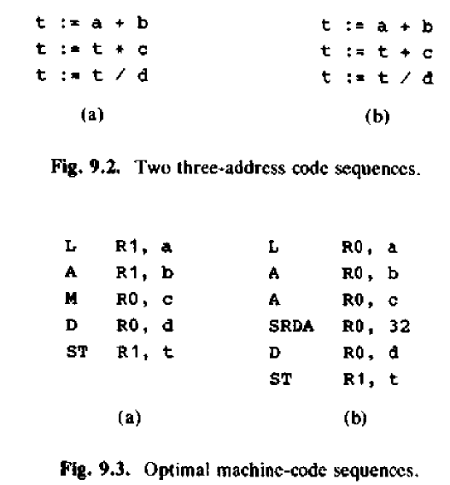

Q31. What is Choice of Evaluation Order and Approaches to Code Generation?
Evaluation order – The code generator decides the order in which the instruction will be executed. The order of computations affects the efficiency of the target code. Among many computational orders, some will require only fewer registers to hold the intermediate results. However, picking the best order in the general case is a difficult NP-complete problem.
Approaches to code generation issues: Code generator must always generate the correct code. It is essential because of the number of special cases that a code generator might face. Some of the design goals of code generator are:
  - Correct
  - Easily maintainable
  - Testable
  - Efficient
Code Generation Approaches:
- Basic Code Generation:
  - A straightforward algorithm that generates code for a register machine by considering subsequent uses of operands and keeping them in registers as long as possible.
  - Optimized by techniques like peephole optimization to improve the output.
- Register Allocation Optimization:
  - Techniques for better register usage by considering the flow of control, particularly for operands used heavily in inner loops.
- Retargetable Code Generation:
  - Techniques like tree-directed code selection make it easier to construct code generators that can be adapted to different target machines.
  - Example: PCC, the portable C compiler, which has been ported to many machines and contributed to the widespread use of UNIX.
- Tree-Rewriting Process:
  - Code generation can be treated as a tree-rewriting process to simplify and optimize the generation of target code.
Q32. What is simple target machine model? Explain with example.
The simple target machine model describes a simplified version of a computer architecture, focusing on a few basic instructions to illustrate the principles of code generation. This model is used for teaching and understanding how compilers generate assembly code for a hypothetical machine.

Characteristics:
- Three-address machine: This machine allows operations to involve three operands: a destination and two source operands.
- Byte-addressable memory: Each address in memory corresponds to one byte, making it easy to access and store values.
- Registers: The machine has multiple general-purpose registers (R0, R1, ..., Rn-1) to store intermediate results and data during computation.
- Instruction Set: The instruction set includes basic operations like load, store, arithmetic operations, and conditional jumps. The operations are simple to reduce complexity and focus on the core principles.

Types of Instructions:
- Load Operations:
  - LD dst, addr: Loads the value from memory location addr into register dst.
  - Example: LD R1, y loads the value from y into register R1.
- Store Operations:
  - ST x, r: Stores the value in register r into memory location x.
  - Example: ST x, R1 stores the value in R1 into memory location x.
- Computation Operations:
  - OP dst, src1, src2: Applies the operation OP (like ADD, SUB) on the values from src1 and src2, storing the result in dst.
  - Example: SUB R1, R1, R2 subtracts the value in R2 from R1 and stores the result back in R1.
- Unconditional Jump:
  - BR L: Unconditionally branches to the instruction labeled L.
  - Example: BR L1 jumps to the instruction at label L1.
- Conditional Jump:
  - Bcond r, L: Conditionally branches to label L if a specific condition (like less than, equal to, etc.) is true for the value in register r.
  - Example: BLTZ R1, L2 jumps to label L2 if the value in R1 is less than zero.

Example: Translating a Three-Address Statement
Consider the statement x = y - z. This can be translated into machine instructions as follows:
LD R1, y // R1 = y
LD R2, z // R2 = z
SUB R1, R1, R2 // R1 = R1 - R2
ST x, R1 // x = R1
Here:
- LD R1, y loads the value of y into register R1.
- LD R2, z loads the value of z into register R2.
- SUB R1, R1, R2 performs the subtraction R1 = R1 - R2.
- ST x, R1 stores the result of the subtraction into memory location x.
This model simplifies the process of code generation and highlights the basic instructions necessary to perform common operations on a target machine.
Q33. Explain A Simple Coded Generator. With Example.
A simple code generator translates a sequence of three-address intermediate code statements into target assembly or machine code. The strategy aims to efficiently generate target code by considering the operands' locations and reusing registers as much as possible. The goal is to reduce memory accesses and minimize instruction costs.

Key Points:
- Register Usage: The code generator aims to keep operands in registers for as long as possible, storing them only when necessary (e.g., before jumping or before leaving a basic block).
- Basic Block: A basic block is a sequence of instructions that always execute sequentially. Data must be stored when crossing basic block boundaries, to ensure that data is not lost when entering a different block.
- Instruction Selection: For each operation, the generator selects a corresponding machine instruction. The selection depends on where operands are located (in registers or memory).

Example:
Consider the three-address statement:
a := b + c

Case 1: Both b and c are in registers
If b is in register R1 and c is in register R2, we can directly use an ADD operation:
ADD R1, R2 // R1 = R1 + R2
Here, the result is stored in register R1. This sequence has a cost of 1 since no memory access is required.

Case 2: One operand is in memory
If b is in register R1 but c is in memory (location C), we can generate:
ADD C, R1 // R1 = R1 + C
This has a cost of 2 since we load c from memory into the computation.
Alternatively, if c is used later, we might prefer:
MOV C, R2 // R2 = C
ADD R1, R2 // R1 = R1 + R2
This sequence has a cost of 3, but it saves an additional memory access if c is used later in the code.

Case 3: Both operands are constants
If both b and c are constants, the generator can generate:
ADD b, c // R1 = b + c
This is efficient, with no need for registers, assuming the target machine can directly perform arithmetic on constants.

Case 4: Operator is commutative
If the addition operator is commutative (i.e., b + c = c + b), the code generator might optimize by swapping operands to optimize for available registers. For example, if c is in memory and b is in a register, we could generate:
ADD R1, C // R1 = R1 + C
instead of loading C into a register first.
Q34. What is Register and address descriptors?
Register and Address Descriptors
- Register Descriptor: A register descriptor keeps track of what is currently in each register. It is consulted whenever a new register is needed. Initially, all registers are empty. As the code generation for the block progresses, each register will hold the value of zero or more names at any given time.
- Address Descriptor: An address descriptor keeps track of the location (or locations) where the current value of the name can be found at runtime. The location might be a register, a stack location, a memory address, or some set of these. This information can be stored in the symbol table and is used to determine the accessing method for a name.
Q35. Explain the construction of a basic block using DAG?
Directed Acyclic Graphs (DAGs) are useful data structures for implementing transformations on basic blocks. A DAG visually represents how values computed by each statement in a basic block are used in subsequent statements. Constructing a DAG from three-address statements helps identify common subexpressions, variables used inside but evaluated outside the block, and which statements' computed values could be used outside the block.
A DAG for a basic block has the following characteristics:
- Leaves: These nodes are labeled with unique identifiers such as variable names or constants. They represent the initial values of names and are typically labeled as r-values. To avoid confusion with "current" values, these initial values are often subscripted with 0 (e.g., x0).
- Interior Nodes: These nodes are labeled with operator symbols, representing computed values. The nodes store the result of an operation applied to its operands.
- Labels on Nodes: Nodes can also have a sequence of identifiers for labels. These identifiers are associated with the computed value represented by the node.
It is essential to distinguish DAGs from flow graphs. While each node of a flow graph can be represented by a DAG, the flow graph represents a basic block, and the DAG shows the detailed structure of the computations within the block.

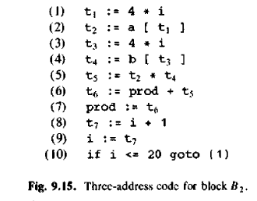
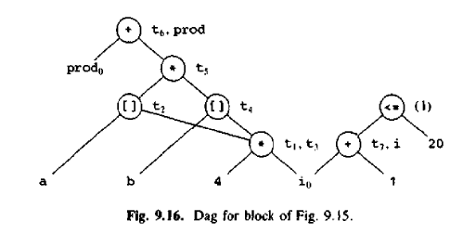
‘

Q36. Explain Peephole Optimization in detail.
Peephole optimization is a technique used to locally improve target code by examining a small, sliding window of instructions (called the "peephole") and replacing sequences of instructions with shorter or faster alternatives, whenever possible. The goal is to enhance the efficiency of the generated code by reducing unnecessary operations. It can be applied both to intermediate code and target code. The optimization often requires multiple passes over the code, as each improvement may create new opportunities for further optimizations.
The main types of peephole optimizations include:
- Eliminating Redundant Loads and Stores: If a sequence like LD a, RO followed by ST RO, a exists, the store instruction can be removed because the value of a is already in register RO. This transformation is only safe if the instructions are in the same basic block and there are no jumps that might reorder their execution.
- Eliminating Unreachable Code: Unreachable code, such as instructions following an unconditional jump, can be eliminated. For example, in a sequence where debugging code is conditional, we can optimize by removing unnecessary jumps or unreachable instructions. Through constant propagation and simplification, unreachable code can be identified and removed.
- Flow-of-Control Optimizations: These optimizations remove unnecessary jumps in the control flow. For example:
  - A jump-to-jump sequence like goto L1; L1: goto L2 can be simplified to goto L2.
  - Similarly, conditional jumps to unconditional jumps can also be simplified, improving the execution flow.
- Algebraic Simplification and Reduction in Strength: Algebraic identities can be used to simplify expressions, such as eliminating x = x + 0 or x = x * 1. Also, expensive operations can be replaced with cheaper equivalents. For example, squaring x (i.e., x^2) can be replaced by x * x, which is often less costly than using an exponentiation routine. Multiplication or division by powers of two can be replaced with shifts.
- Use of Machine Idioms: Machine-specific features, such as hardware instructions for specific operations, can be exploited for optimization. For example, some machines have special modes like auto-increment and auto-decrement addressing, which can optimize operations like stack manipulation or incrementing variables, thus improving performance.
Peephole optimization improves code by eliminating unnecessary operations, reducing instruction count, and leveraging hardware-specific features, leading to more efficient and faster execution.
Q37. Explain all peephole optimization technique in detail.
1. Eliminating Redundant Loads and Stores
Redundant loads and stores occur when a value is loaded into a register and then immediately stored back to the same location without any modification. This sequence is unnecessary because the store will overwrite the value that was just loaded. In peephole optimization, such sequences can be eliminated to save time and memory access.
For example, consider the sequence:
LD a, RO // Load the value of 'a' into register RO
ST RO, a // Store the value of RO (which is 'a') back to memory location 'a'
The store instruction is redundant since the value of 'a' is already loaded into register RO, and no modification is made to it. Thus, the store instruction can be eliminated, and the sequence reduced to just:
LD a, RO
This transformation is safe only if the load and store instructions are in the same basic block, meaning no jumps or control transfers between them that could alter the execution order. Otherwise, the store instruction should be retained because the program's flow may require it.
2. Eliminating Unreachable Code
Unreachable code is code that will never be executed due to control flow mechanisms, such as unconditional jumps or infinite loops. Peephole optimization identifies and removes such instructions, reducing unnecessary computations and improving performance.
For instance, consider this code:
if debug == 1 goto L1
goto L2
L1: print debugging information
L2: some other code
If the value of debug is always 0, the condition debug == 1 will never be true. This makes the jump to L1 unnecessary, and the entire block with L1: print debugging information becomes unreachable.
Peephole optimization can propagate constants, resulting in:
if 0 == 1 goto L2 // This is always false
print debugging information
L2: some other code
Now the jump instruction if 0 == 1 is redundant and can be removed, as the code sequence becomes simpler and more efficient.
3. Flow-of-Control Optimizations
This type of optimization deals with improving the flow of control in a program by eliminating unnecessary jumps or simplifying control structures. This reduces the number of jump instructions and simplifies the execution flow, resulting in faster execution.
For example, a jump-to-jump sequence like:
goto L1;
L1: goto L2;
Can be optimized by directly replacing it with:
goto L2;
In the case of conditional jumps, we can simplify a conditional jump followed by an unconditional jump:
if condition goto L1;
goto L2;
L1: some code
If L1 is always reached by the first jump, the second jump to L2 is redundant. This can be optimized as:
if condition goto L1;
some code
If the condition is always true, the sequence can be further reduced to:
some code
4. Algebraic Simplification and Reduction in Strength
Algebraic simplifications involve applying basic algebraic identities to remove unnecessary operations. This includes eliminating operations that do not change the result, such as adding zero or multiplying by one. These simplifications reduce instruction count and improve efficiency.
Examples include:
- Eliminating x = x + 0: Since adding zero does not change the value of x, this operation can be eliminated:
x = x + 0 → x
- Eliminating x = x * 1: Similarly, multiplying by one does not change the value of x, so this operation can also be eliminated:
x = x * 1 → x
Reduction in strength is an optimization where expensive operations are replaced by cheaper ones. For example:
- Using shifts instead of multiplications or divisions by powers of two:
x = x * 2 → x = x << 1 // Shift left by 1 bit
x = x / 2 → x = x >> 1 // Shift right by 1 bit
These transformations make the code more efficient because shifts are often much cheaper to execute than multiplications or divisions.
5. Use of Machine Idioms
Machine idioms refer to hardware-specific features or instructions that can be used to optimize certain operations. Some processors offer specialized instructions or addressing modes that can perform specific tasks more efficiently than general instructions.
For example, some processors support auto-increment and auto-decrement addressing modes, which automatically modify an operand after it is accessed. These modes can be used to optimize operations like stack manipulations or array indexing.
Consider the following code for pushing a value onto the stack:
push x // Decrement SP and store x at the new SP location
With auto-decrement addressing, the same operation can be performed more efficiently with a single instruction that decrements the stack pointer and stores the value, reducing the instruction count and improving performance.
Additionally, processors may have special instructions for performing operations like multiplication or division by constants. These can be used in place of more expensive operations. For example:
- Using multiplication by a constant instead of division by a constant: If division by a constant is slow, a peephole optimizer might replace a division operation with a multiplication by the reciprocal of the constant.
By exploiting these hardware features, the optimizer can improve the performance of the generated code by taking advantage of the target machine's capabilities.
In summary, peephole optimization is a powerful technique for enhancing the performance of compiled code. It involves improving the efficiency of code by eliminating redundant operations, simplifying control flow, applying algebraic simplifications, and utilizing machine-specific idioms.

Q38. Explain Register Allocation and Assignment in detail.
Register Allocation and Assignment:
Register allocation and assignment are crucial steps in code optimization, ensuring that frequently used values are stored in fast registers rather than slower memory locations. Modern processors have much faster register access times compared to memory, so efficient use of registers significantly improves performance.

1. Register Allocation
This is the process of deciding which variables or values should reside in registers at various points during the program execution. The goal is to minimize memory access and optimize the use of limited registers. The general idea is to keep the most frequently used variables in registers as long as possible, reducing the need for memory accesses.
There are two main approaches to register allocation:
- Local Register Allocation: This involves allocating registers to values within a single basic block. A basic block is a sequence of consecutive instructions with no branches (except at the entry and exit). In the code generation algorithm, registers are used to hold variables only for the duration of a basic block, and values are stored at the end of the block. This method is simple but may involve unnecessary memory operations when the same value is needed across block boundaries.
- Global Register Allocation: This approach extends the allocation to cover multiple basic blocks across the entire program, ensuring that frequently used values are kept in registers across block boundaries. It also tries to maintain values in registers across loop boundaries, particularly for inner loops, which are performance hotspots in most programs.
Global register allocation typically works by:
- Assigning a fixed number of registers to hold the most frequently used values in each loop.
- Using the remaining registers for variables that are local to a single basic block.
- Ensuring that values that are live across block boundaries are stored in registers, reducing unnecessary load/store operations.

2. Register Assignment
Once the variables to be allocated to registers are decided (through register allocation), the next step is register assignment, which determines exactly which register will hold each value. The main goal is to efficiently assign registers to variables while avoiding conflicts or excessive spills (when a variable must be saved to memory due to a lack of available registers).

3. Usage Counts
To determine which variables should be assigned to registers, usage counts can be used. The more frequently a variable is accessed within a loop or basic block, the higher its usage count and the more valuable it is to be stored in a register. The following are important aspects related to usage counts:
- Savings from keeping a variable in a register: The key advantage of keeping a variable in a register is the time saved by avoiding memory access. If a variable x is kept in a register for the duration of a loop, each reference to x (without reloading from memory) provides a unit of savings in execution time. If x is used frequently in the loop, the savings accumulate.
- Savings from avoiding stores: At the end of each basic block, variables are typically stored back to memory. If a variable is still alive (i.e., will be used later), keeping it in a register can avoid unnecessary store operations. For example, if x is live on exit and is allocated a register, a savings of two units can be achieved by avoiding the store operation.
Thus, when allocating registers for variables, a savings count is maintained based on how often the variables are used and whether they remain live across block exits. This allows the optimizer to make decisions based on the frequency of use and how critical a variable is in terms of execution efficiency.

4. Approaches for Global Register Allocation
- Fixed-Register Allocation in Loops: This approach assigns a fixed number of registers to the most active values in inner loops. These registers may vary across different loops depending on the values that are most frequently accessed. While simple, this method may not always allocate the optimal number of registers for each loop, leading to inefficiencies.
- Profiling and Manual Allocation: In earlier compilers, such as those for Fortran, programmers could provide hints about which variables should be kept in registers using explicit register declarations. By profiling the program to identify hotspots, a programmer could manually guide the compiler in register allocation to improve performance. While this could improve execution time, it required careful analysis and expertise.

5. Example of Register Allocation
Consider a loop where a variable x is used multiple times:
for i = 1 to N:
x = x + 1 // x is updated and used in every iteration
y = x * 2 // y depends on x
Without register allocation, every time x is used or updated, it may need to be loaded from memory, leading to significant overhead. However, by allocating a register for x, both the addition and multiplication can be performed in the register without reloading x from memory.
If the loop is nested or has multiple exit points, efficient global register allocation ensures that x remains in a register for as long as possible, reducing the number of memory accesses.

6. Trade-offs in Register Allocation
- Fixed vs. Dynamic Allocation: Fixed allocation (where certain registers are reserved for specific purposes like base addresses or stack pointers) is easier to implement but may lead to underutilization of registers. Dynamic allocation allows for better register usage but requires more sophisticated algorithms to track live variables and register allocation across basic blocks.
- Number of Registers: Register allocation algorithms must balance the number of available registers with the program’s requirements. If too few registers are allocated, memory access will increase, slowing down the program. If too many registers are used, the complexity of the algorithm increases, and the benefits may not outweigh the costs.
- Spills and Reloads: When a variable cannot be allocated a register (because all registers are occupied), it must be stored in memory, which introduces a "spill." Reloading these variables from memory when needed adds overhead, so minimizing spills is a key objective of efficient register allocation.
Q39. What is Basic Block? Explain transformation of basic blocks?
A basic block is a sequence of consecutive statements in a program where the flow of control enters at the beginning and leaves at the end without any interruptions or branches, except at the end. In other words, it is a straight-line code with no loops or branches within it. Each basic block is typically executed in its entirety, and once entered, control flows sequentially through the block until it reaches an exit point.
For example, consider the following sequence of three-address code statements:
t1 := a * a
t2 := a * b
t3 := 2 * t2
t4 := t1 + t3
t5 := b * t1
t6 := t4 + t3
This sequence represents a basic block because all statements are executed sequentially, and the flow enters at the top and leaves at the end, with no branching in between. Basic blocks are fundamental in program analysis and optimization because they allow compilers to reason about the flow of control and data.

Transformation of Basic Blocks
Transformations on basic blocks involve applying specific techniques that modify the block while preserving its semantics (i.e., the set of expressions it computes). These transformations are crucial for optimizing code and improving performance. Some of the common transformations include:
- Common Subexpression Elimination (CSE):
This optimization seeks to identify and eliminate redundant calculations. If a particular expression is computed multiple times within a basic block, it can be calculated once and stored in a temporary variable to avoid recomputing it. For example, if both t1 := a * a and t2 := a * a appear in a basic block, the second one can be eliminated by using the result of the first.
- Dead-Code Elimination (DCE):
Dead-code elimination removes any computations that do not affect the final result or are never used (i.e., the values are never read after being computed). For example, if a variable is computed but never used later in the program, it is considered dead code and can be removed to improve efficiency.
- Renaming of Temporary Variables:
Renaming temporary variables can help in minimizing conflicts and improving register usage. This transformation is useful for reducing unnecessary dependencies between instructions and simplifying the intermediate representation of a program.
- Interchange of Two Independent Adjacent Statements:
If two adjacent statements in a basic block are independent of each other (i.e., they don't share any variables or have data dependencies), they can be swapped without changing the behavior of the program. This transformation can improve the instruction scheduling by enabling better parallelism or register allocation.

Algebraic Transformations
In addition to structure-preserving transformations, algebraic transformations involve applying mathematical rules to simplify or rearrange expressions within a basic block. These transformations are based on algebraic identities, such as:
- Constant Folding:
Simplify expressions involving constant values. For example, t1 := 3 * 2 can be replaced by t1 := 6.
- Constant Propagation:
If the value of a variable is constant at a given point, the variable can be replaced by the constant in subsequent expressions. For instance, if a := 5 is known, and b := a * 2 appears later, it can be simplified to b := 10.
- Simplification of Expressions:
Simplify more complex expressions using known algebraic rules. For instance, t1 := a + 0 can be simplified to t1 := a.

Advantages of Basic Block Transformations
These transformations improve the quality of generated code in several ways:
- Reduction in Execution Time: By eliminating redundant computations (such as common subexpressions) and removing dead code, the number of instructions in a program is reduced, leading to faster execution.
- Optimized Memory Usage: By simplifying expressions and renaming temporary variables, the memory usage (particularly register usage) is optimized.
- Improved Parallelism: Transformations like reordering independent statements can help the compiler generate code that better utilizes available execution units, increasing parallelism.

Algorithm for Partitioning a Sequence into Basic Blocks
To partition a sequence of three-address statements into basic blocks, we can use the following approach:
- Identify the Start of Each Basic Block:
A new basic block starts when one of the following occurs:
  - The first instruction in the sequence.
  - A branch or jump instruction.
  - A label instruction that marks the entry point of a new block.
- Identify the End of Each Basic Block:
A basic block ends when one of the following occurs:
  - A branch or jump instruction that leads to another basic block.
  - A return instruction or any instruction that exits the function or procedure.
- Group Consecutive Statements into Blocks:
After identifying the start and end points, group all consecutive statements between these points into a basic block.

Example
Given the following sequence of statements:
t1 := a * a
t2 := a * b
if (x > 0) goto L1
t3 := 2 * t2
t4 := t1 + t3
goto L2
L1: t5 := a + b
L2: t6 := t1 + t2
- Basic Block 1:
t1 := a * a t2 := a * b if (x > 0) goto L1
- Basic Block 2:
t3 := 2 * t2 t4 := t1 + t3 goto L2
- Basic Block 3:
L1: t5 := a + b
- Basic Block 4:
L2: t6 := t1 + t2

Q40. Explain Flow Graphs.
A flow graph is a directed graph that adds flow-of-control information to a program by using basic blocks as nodes. The flow graph helps visualize how control moves through a program.

Components of a Flow Graph
- Nodes:
Each node in the flow graph represents a basic block, which is a sequence of consecutive statements where control enters at the beginning and leaves at the end without any halt or branching except at the end.
- Edges:
Directed edges between nodes represent possible control flows between basic blocks. There is an edge from block B1B_1 to block B2B_2 if:
  - There is a conditional or unconditional jump from the last statement of B1B_1 to the first statement of B2B_2, or
  - B2B_2 immediately follows B1B_1 in the program, and B1B_1 does not end in an unconditional jump.

Flow Graph Construction
- Initial Block:
The node corresponding to the first basic block (whose first statement is executed when the program starts) is designated as the initial block.
- Predecessor and Successor:
  - Block B1B_1 is a predecessor of block B2B_2 if there is an edge from B1B_1 to B2B_2, indicating that control can flow from B1B_1 to B2B_2.
  - Block B2B_2 is a successor of block B1B_1 if there is an edge from B1B_1 to B2B_2, meaning control can flow from B1B_1 to B2B_2.

Example
If block B1B_1 contains a sequence of statements and block B2B_2 immediately follows B1B_1 in the program, with no unconditional jump in B1B_1, then an edge is drawn from B1B_1 to B2B_2.
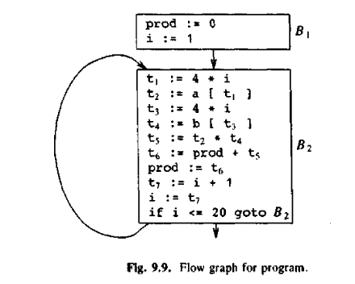

Q41. Write short in on Loop unrolling and Loop jamming.

Loop Unrolling:
Loop unrolling is a technique used to optimize loops by increasing the number of operations performed in each iteration. It works by replicating the body of the loop multiple times, reducing the overhead of loop control (such as incrementing the loop variable and checking the loop condition) and thus improving performance. This is especially beneficial for loops that have small bodies with relatively high control overhead.
For example, a loop like:
for (i = 0; i < n; i++) {
a[i] = b[i] + c[i];
}
Can be unrolled as:
for (i = 0; i < n; i += 2) {
a[i] = b[i] + c[i];
a[i + 1] = b[i + 1] + c[i + 1];
}
This reduces the loop overhead and can improve performance by executing more computations per iteration.

Loop Jamming:
Loop jamming (also known as loop fusion) is a technique where two or more loops that iterate over the same range of indices are combined into a single loop. This reduces the overhead of multiple loops and improves cache locality by keeping related data in the cache for a longer time.
For example, given two loops:
for (i = 0; i < n; i++) {
a[i] = b[i] + c[i];
}
for (i = 0; i < n; i++) {
d[i] = a[i] * 2;
}
These can be jammed into one loop:
for (i = 0; i < n; i++) {
a[i] = b[i] + c[i];
d[i] = a[i] * 2;
}
This reduces the number of loop iterations and improves data locality, which can boost performance.
Q42. What are the recovery method used by each phase of the compiler?
- Lexical Analysis:
  - Panic Mode: Skips invalid tokens.
  - Phrase-Level: Rarely used.
  - Error Productions & Global Correction: Not applicable.
- Syntax Analysis:
  - Panic Mode: Skips input to a synchronizing token.
  - Phrase-Level: Fixes grammar locally (insert/delete tokens).
  - Error Productions: Handles common syntax errors.
  - Global Correction: Rarely used (expensive).
- Semantic Analysis:
  - Panic Mode: Skips sections with semantic violations.
  - Phrase-Level: Default fixes (e.g., type corrections).
  - Error Productions: For type/scoping issues.
  - Global Correction: Not used.
- Intermediate Code Generation:
  - Panic Mode & Global Correction: Rarely used.
  - Phrase-Level: Adjusts problematic constructs.
  - Error Productions: Not typical.
- Code Optimization:
  - Panic Mode & Global Correction: Not applicable.
  - Phrase-Level: Skips invalid optimizations.
  - Error Productions: Rarely used.
- Code Generation:
  - Panic Mode: Skips faulty instructions.
  - Phrase-Level: Replaces errors with default/no-op instructions.
  - Error Productions & Global Correction: Not used.

Q43. What are the issues with Code Generation Design?
The design of a code generator involves addressing several fundamental issues that are common across most target languages and systems. These issues ensure that the generated machine code is both efficient and correct. The primary issues in the design of a code generator include:
Code Generation - Detailed Explanation
In the compiler design process, the code generation phase is the final step where the intermediate representation (IR) of a source program is translated into machine code or assembly code that can be executed on a specific target machine. This phase is complex due to several critical aspects like memory management, instruction selection, and register allocation, which vary depending on the target language and operating system. Below is an explanation of the key concepts involved in code generation:
- Input to the Code Generator:
  - The input consists of the intermediate representation (IR) of the source program, produced by the front end of the compiler, and additional information from the symbol table. The symbol table helps determine the runtime addresses of the data objects referenced in the IR.
  - The IR can take various forms such as linear representations (e.g., postfix notation), three-address representations (e.g., quadruples), virtual machine code (e.g., stack machine code), or graphical representations (e.g., syntax trees and DAGs).
  - The input is assumed to be free of errors, having already undergone semantic checks like type checking and semantic error detection. This ensures that the code generation phase can proceed without handling such errors.
- Target Programs:
  - The output of the code generator is the target program, which can be produced in different forms:
    - Absolute Machine Language: This is a fixed location in memory, and the generated code can be executed directly.
    - Relocatable Machine Language: This allows separate compilation of subprograms. These modules can be linked together and loaded for execution. This method is more flexible and is used in larger programs.
    - Assembly Language: In some cases, the code generator produces assembly language, which can then be assembled into machine code by an assembler.
- Memory Management:
  - Mapping the names in the source program to memory addresses is a crucial task. The code generator works in tandem with the front end, which has already created symbol-table entries for variables and their types.
  - Static and stack-based memory allocation schemes are used to map variables to their memory locations. The addresses for variables are determined based on the information available in the symbol table.
  - For machine code generation, labels in three-address statements are translated into instruction addresses, a process akin to "backpatching."

- Instruction Selection:
  - The selection of appropriate machine instructions depends on the instruction set of the target machine. The complexity of this task varies depending on the uniformity and completeness of the instruction set.
  - Instruction selection is straightforward if efficiency is not a concern. For example, simple three-address statements like x := y + z could be directly translated into a sequence of machine instructions.
  - However, if the goal is to optimize performance, instruction selection becomes more complex. For instance, redundant computations, like those seen in repeated variable assignments, need to be avoided by recognizing opportunities to reuse results.
- Register Allocation:
  - Efficient use of registers is critical for generating fast and optimized code, as operations using registers are faster than those involving memory operands.
  - Register allocation involves two phases:
    - Register Allocation: This phase selects the set of variables that will be stored in registers during program execution.
    - Register Assignment: This phase assigns specific registers to the selected variables.
  - Optimal register allocation is a difficult problem and is often NP-complete. Moreover, some machines have specific register usage conventions, such as requiring register pairs for certain operations (e.g., integer multiplication and division in the IBM System/370).
Q44. What are the types of Code-Improving Transformations?
Code-Improving Transformations are compiler optimizations aimed at enhancing the performance or efficiency of a program without altering its functionality. These transformations are categorized into function-preserving and performance-enhancing techniques. Below are key code-improving strategies:

Function-Preserving Transformations
- Common Subexpression Elimination:
Eliminates repeated computations of the same expression by reusing previously computed values.
Example:
t1 = a + b;
t2 = a + b;
Optimized to:
t1 = a + b;
t2 = t1;
- Copy Propagation:
Replaces variables that are mere copies of others with their source variable.
Example:
x = y;
z = x;
Optimized to:
x = y;
z = y;
- Dead-Code Elimination:
Removes code that computes values never used later.
Example:
x = y + 5;
z = x;
If z is unused, both statements are removed.
- Constant Folding:
Simplifies expressions with constant values at compile time.
Example:
x = 2 * 3;
Optimized to:
x = 6;

Performance-Enhancing Transformations
- Loop-Invariant Code Motion:
Moves computations that yield the same result on every loop iteration outside the loop.
Example:
for (i = 0; i < n; i++) {
x = y + z;
a[i] = x * i;
}
Optimized to:
x = y + z;
for (i = 0; i < n; i++) {
a[i] = x * i;
}
- Strength Reduction:
Replaces expensive operations (e.g., multiplication) with cheaper equivalents (e.g., addition).
Example:
for (i = 0; i < n; i++) {
x = i * 4;
}
Optimized to:
x = 0;
for (i = 0; i < n; i++) {
x += 4;
}
- Peephole Optimization:
Examines a small set of instructions to replace inefficient sequences with faster ones.
Example:
Replace:
MOV R1, 0
ADD R1, R2
With:
MOV R1, R2
- Code Motion:
Moves computations out of frequently executed paths to reduce runtime.
Example:
Calculating a constant expression outside a loop or condition block.
These transformations collectively improve program execution speed, reduce resource usage, and sometimes reduce code size. However, they are applied cautiously to ensure program correctness is never compromised.
Q45. What is the use of symbol table? Explain the any two data structures associated with symbol table in detail.
A symbol table is a data structure used in compilers and interpreters to store information about variables, functions, objects, and other identifiers during program execution. It helps in managing the scope, type, and value of these identifiers while the program is being compiled or interpreted. It is essential for semantic analysis and code generation tasks.
Q46. Write short note on the following:
a) Loop unrolling & Loop jamming
b) Code generation
Q47. Write short note on the following:
a) Basic blocks & flow graph
b) Peephole optimization
Q48. Explain the various types of errors generated during the various phases of the compiler. How do we recover from these errors?

